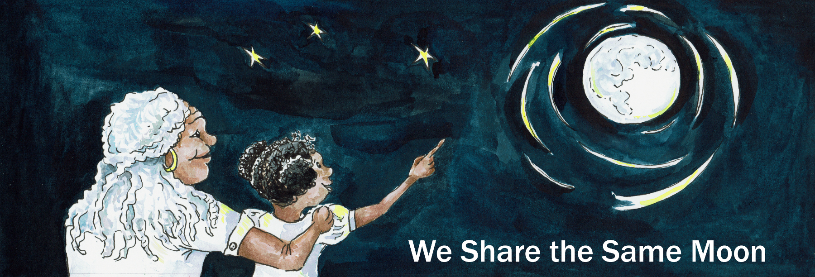
Suggested Age Range: 5 - 6 years; 6 - 7 years; 7 - 8 years; 9 - 10 years; Adult
UK Curriculum: Key Stage Two (Upper)
Suggested UK Year Group: Year Five
UK Primary Curriculum Link: Earth and Space
Science Subject: Stars
Science Questions: What are Stars?
Suggested Science Activity: Constellations
Children with SEND: Use to boost speech and language development
EAL children: Intermediate Level
Country of Origin: Celtic Tradition of England
Source: A Maid of the North, by Ethel Johnston Phelps

Long ago, it was said that there was two worlds. The real world where real people lived and the imagined world where the fair folk lived. These two worlds lay apart and their paths never crossed, except at certain times of the year. The longest day and the longest night.
There was once a young girl who more than anything else in the world wanted to reach for the stars. She did not just want to see them, she wanted to touch them.
Of course all of her family thought this was a ridiculous idea..
“Don’t be so foolish! You cannot go the Stars! You’ll be wanting to go the Moon next!”
They urged her to forget her dream. But she could not.
One night, on the longest night of the year, she woke up in the middle of the night. Through a crack of the curtains, she could see the stars shining so brightly, the light was pouring into her room. She pulled the curtains open and looked out.
The stars were so bright, it was as if they were calling to her Come to us, come to us, come and reach the stars She knew she could not, it was an impossible dream.
But, on this starry night, it seemed that anything might be possible.
So very slowly and quietly, she got out of bed, pulled on her clothes and crept downstairs and opened the door.
But, as she took her first step outside she realised something! She had left her shoes upstairs. It was so cold. How could she walk barefoot to the stars?
But to turn back, would be to break the spell, to disturb the dream.
So she did not. She started to follow the stars. Their silver light led her through the grass, towards the forest at the edge of her garden.The grass was so cold under her feet, the ground was crisp and frozen, she could feel her toes turn to ice.
But she carried on walking.
She reached the edge of the garden and opened the gate into the wood and began to walk through the trees. The light of the stars led her to a stream and she crossed it, her feet turning into blocks of ice as the cold water flowed around her.
But she carried on walking, ...
The light of the stars led her to a lake, she swam across it, her body shuddering and juddering with cold.
But she carried on walking ...
The light of the stars led her to a mountain and she climbed it, always following the light of her dreams. At the top of the mountain, the fair folk were dancing as silver as the stars. She begged them to help her follow her dream.
You must answer this riddle. They said:
You must walk down the mountain - looking neither left nor right. And at the bottom of the mountain - you must find Four Feet. And then you must ask Four Feet - to carry you to No Feet.
And you must ask No Feet - to carry you to The Stairs without Steps. And you must climb The Stairs without Steps ....
And then will I reach the Stars?
Perhaps - was all they said
And so she carried on walking
Down the mountain, as straight as an arrow, until she found a horse who carried her to the edge of the world, where land meets ocean. At the ocean’s edge, she met a dolphin, who carried her to a rainbow. She climbed the rainbow….
And there were the stars! Just within reach! She stretched and stretched and stretched ...
And fell!
Tumbling, twisting, turning back into sleep.
And woke the next day, safe in her bed, sunlight streaming through her window.
Was it just a dream?
Maybe it was.
But, when she looked at her hand it was clenched tight like a fist. She opened her fingers and there ion her palm was a tiny piece of stardust.
So she knew that she had reached the stars, for real.
And she passed that piece of stardust on to her children and her children’s children, and they passed it on to their children’s children
As I am passing the story onto you...
So - do YOU think you can reach the Stars?
Perhaps.
Copyright Cassandra Wye April 2019

