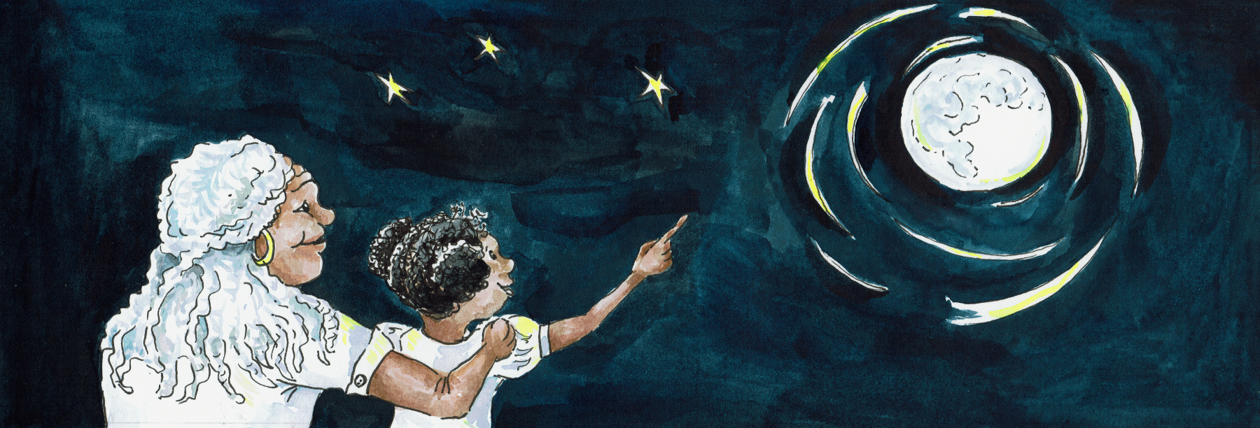
Suggested Age Range: 7 - 8 years; 9 - 10 years; Adult
UK Curriculum: Key Stage Two (Upper)
Suggested UK Year Group: Year Four; Year Five
UK Primary Curriculum Link: States of Matter; Earth and Space
Science Subject: Stars
Science Questions: What are Stars? What are Constellations?
Suggested Science Activity: Star Crowns; Constellations
Children with SEND: Use to boost speech and language development
EAL children: Intermediate Level
Country of Origin: First Nations of America
Source: Ring on the Prairie by Lynn Moroney

Long ago, in the Prairies of America, where the tall, tall grass stretches as far as the eye can see …
There was once, a young man who went walking at night, following the light of the stars. There was no cloud in the sky, and as he walked he looked up and marvelled to see the sky shimmering from blue to black and the stars so silver and bright.
“This” he said to himself, “is a special night.”

And as he walked he continued to gaze up at the sky. And he noticed that one of the stars seemed to be shining brighter than all the rest. And then he noticed that it seemed to be moving, to be drifting slowly, slowly down to Earth.
And as it came closer, he saw that it was not just one star, but a circle of seven stars, and each star in the circle seemed brighter than the one before.
And then, he stopped still, for just ahead of him, there was a clearing, where the tall grass had been trampled down, underfoot. The circle of stars seemed to be heading straight towards the clearing!What could this mean?

He stopped, hidden within the long grass at the edge of the clearing and waited.He watched as the stars drifted one by one down to earth.
And then, as each star touched the earth, the air seemed to shimmer and the star changed into human form! How could this be true?

He watched, as one after the other the stars reached, touched the Earth and changed. And each star maiden that appeared, seemed more beautiful than the one before. Until at last, the seventh star, the one that had shone the brightest, touched the ground and turned into the most beautiful maiden he had ever seen.

And then, whilst Algnon breathed as slowly and as silently as a human can, he saw the maidens take each other by the hand and to begin dancing around and around weaving a pattern on the ground that seemed to match the patterns that the stars danced across the Sky. Once their dance was over, one by one they looked up and jumped into the sky. And one by one, they changed back into a star and drifted back to their place in the sky.
That night, when Algnon finally slept, he dreamed of these star maidens, and when he woke, he was convinced that all that he had seen, must have been a dream.
But, the next night, he found himself walking back to the clearing and hiding once again. And once again, the circle of stars floated down to Earth, one by one, and one by one changed into human form and began dancing together around and around.
Oh - and the seventh star really was the most beautiful girl he had ever seen!
“This is the one I want to marry!" he said to himself.
And so, when the dance was over, he edged closer and closer and closer and when the seventh sister was about to dance into the sky - he grabbed hold of her!
“Let me go!” she cried and she struggled “ Let me go with my sisters. My place is in the sky”
“Please” he begged “Please, stay with me on Earth, just for a while”
And when she looked into his eyes and saw only kindness there, she agreed.
So she stayed for a while, and a while grew longer. And after a while they were married and a while, they had a son. But soon after that, the star maiden began to feel sad. She missed her home.

“ I want to go home” she said to Algnon. “ I miss the sky. I miss my family, I miss dancing with my sisters. It is time for me to return”

And Algnon knew it would be wrong to keep her with him against her will
“Very well”. He said. But, if you wish, I will come with you.” And she turned to him and smiled. And so, holding him and her child close together in her arms, she jumped up into the sky.And to Algnon’s delight he found himself changing, as his wife and son were changing, into stars. And they drifted up towards the circle of stars.

As they drifted closer and closer to the circle of stars, they saw the sisters take on their human form and come tumbling through the sky towards them. Shouting and laughing with joy, the stars grabbed their sister, their nephew, their brother in law.
And the sisters took them to meet their Sky-father and mother. Algnon, took from his hair the Hawk feather that he wore and gave it to them as a gift. And as the sky-people touched the feather, they marvelled to see something from Earth up there in the sky. And from that night on, all of the Sky-people came to meet them and rejoice at the return of the Star Maiden, with her star child and her Earth husband.

But as time passed, Algnon found it harder and harder to smile and laugh and dance with everyone. One night, his wife found him off on his own, staring sadly down at the Earth so far below. “Why are you so sad?” she asked
“I miss my home, the feel of the earth between my toes, the cool of the river and the heat of the fire. I do not belong here in the sky"
“But I do not belong on Earth” she replied. “Is there a place, between two worlds, that we can both belong?”
Algnon thought for a while and then he smiled. He looked at his sky-father and held out his hand.
And his sky-father gave him back the Hawk feather and holding it, his wife and child, close together within his arms, Algnon jumped, and slowly the three of them turned from Star to Human to Hawk.

And so, some say, that on a summer night, if you look towards the sky, you can still see them, three silver hawks, flying across the sky - dipping down to Earth and then up to the edge of heaven, sharing the sky together, forever.

And that is why, if you look into the summer sky at night, you might just see, what some call, the corona borealis, what looks like a circle of stars with one star missing - where the stars wait for their sister, the brightest and most beautiful of them to return.

