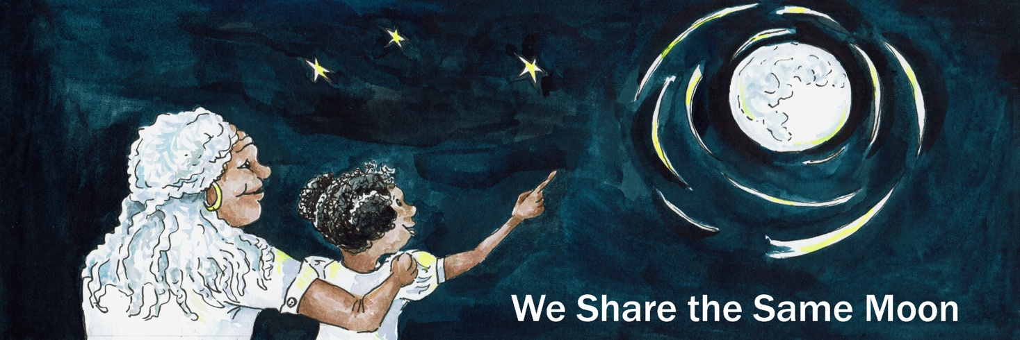

Suggested Age Range: 8 - 9 years: 9 - 10 years
UK Curriculum: Key Stage Two (upper)
Suggested UK Year Group: Year 4, Year 5
UK Primary Curriculum Link: States of matter
Science Subject: Stars; Constellations
Science Question: What are Stars Made of? What are Constellations?
Suggested Science Activity: Star Crowns; Star Maps; Constellations
Children with SEND: Use to boost comprehension of vocabulary
EAL children: Beginners level
Country of Origin: First Nations of America
Source: The Feather Moon by Lynn Moroney

In the beginning, when the world was created, before the humans came,
There was the Earth spinning in the Sky, blue and green and perfect.
All the birds and animals lived together in peace and harmony. Everything was perfect!

But …

The Sun provided light, each and every day, for the day-time animals and they had enough light to see and live by, to find enough food, water and shelter.

But …

At night it was a different story.

For the Moon is never the same. Every night it changed shape and gave different amounts of light. Once a month it was full and very bright and there was enough light in the sky. But then it began to shrink, and then on some nights it would not appear at all!
The animals could not see to find their food or water or shelter, and their life was very hard.

Until finally the night-time animals had had ENOUGH!
They gathered together on the river bank and began to chant
We need more LIGHT
We need more LIGHT! We need more LIGHT! We need more LIGHT!
Up in the heavens the Creator of the Earth slept. And in his dreams he heard troubling sounds, voices shouting at him: We need more LIGHT! We need more LIGHT! We need more LIGHT! We need more LIGHT!
He woke up! There was a crash of thunder CRASH! And a flash of lightening FLASH!
And the heavens opened and there stood the Creator
The animals stopped shouting! And stared and grew silent.
“What is the problem?” asked the Creator

So they told him: “We need more light! The Moon is so unpredictable. She keeps changing shape and sometimes does not appear at all. We need more light at night!”

"Very well” said the Creator“But you will have to help make it!”
“We will!” Said the animals.

“I want each of you to make a pile of special stones, not the round and smooth stones but those that have sharp points. Each of you must make a pile of stones here ion the riverbank. I shall return tomorrow night.”
Well, the animals were overjoyed! They all began to collect some stones. Eagle knew where a pile of sharp stones was to be found, by the riverbank. She flew backwards and forwards all through the day until her pile of stones was huge. Bear, knew too where to find the stones and he strode through the grassland towards the trees towards a huge pile of the special stones. He gathered them all up in his arms and and strode back to the riverbank. His pile of stones was enormous! All of the animals spent all day collecting stones until they each had a pile.

Except for poor butterfly!

He wasn’t very big and he wasn’t very strong. He could only manage to carry one stone at a time, and it took him a very long time to do that. By the end of the day, he had only three stones in his pile. But he was still very proud of what he had done!

That night, all of the animals gathered together at the riverbank and began to chant:
We need more LIGHt! We need more LIGHT! We need more LIGHT!

There was a crash of thunder CRASH!And a flash of lightening FLASH!
And the heavens opened and there stood the Creator once again.
The animals stopped and grew silent. And waited to see what would happen next.
The creator walked up to Fisher. Now Fisher is a cousin of Otter. He has brown fur. He can swim as fast as he can walk. He has webbed feet, bright eyes and a long tail.
And the Creator said: ”May I have one of your stones?”
And Fisher said “Yes”
The Creator took the stone and placed it carefully in the Sky. And the Stone began to shine, brighter and brighter and brighter!
“Wow!’ said the watching animals “What is that?”
“That Is the very first Star. said the Creator “The Star shall shine, each and every night to provide enough light for you all. And this star, the very first star shall be special. Unlike the other stars ,it will not move in the Sky. But instead it will always stay in the same place in the sky and point to the North. It will be called the Home Star, because if you follow this star, you will always be able to find your way home.

“Wow!’ said the watching animals.
“There’s more!” said the Creator. “Watch!”

He took stone after stone from the Fisher’s pile and began to draw a picture of him in the sky. He got the curl of his tail, the length of his legs and the shape of his head - just right!
And when he had finished, there was a picture of Fisher sparkling in the Sky.

“Wow!’ said the animals.

“ There’s more!” said the Creator. “ Tonight, each of you can take your stones and build a picture of yourself in the Sky. And those stars will shine for evermore and for evermore everyone will see you in the Sky!

“Wow!’ said the animals.

And immediately they began flying, running, climbing into the Sky, carrying their stones with them.Eagle went to the East with her pile of stones and began to draw herself in the Sky. And she drew the shape and length and curl of her wings - just right!
Bear went to West and with his pile of stones and began to draw himself in the Sky. And he drew the shape and length and curl of his body- just right!
All the animals were so overjoyed!

Except for poor Butterfly, who was struggling to carry even one stone into the Sky.
“Oh dear” said Butterfly! “I am too small to draw my picture in the Sky. Whatever shall I do?”

The Creator took pity on Butterfly “Who will help Butterfly carry his stones into the Sky?”
“I will, I will, I will!” barked Coyote, the wild dog of the Prairie.
“I will carry his stones for him!”

And so the Creator cut a piece of cloth from the night sky and made it into a bag f and filled it with stones. He gave it to Coyote, who bravely set off to climb the Sky, carrying the bag of stones between his jaws.

But ….
The stones were so heavy and the climb was so long! Coyote’s steps got slower and slower as the bag seemed to get heavier and heavier until at last he stopped, panting, for a rest.There is such a long way to go! And so many stones to carry!

And Coyote began to think: “Surely, Butterfly doesn’t need ALL these stones?
There are so many here in this bag! I wonder if I took some of them out - would he mind? Surely not! There would still be plenty left to draw a picture in the Sky!”

Should Coyote take out the stones? Well, there was no-one nearby to ask.
Neither was there anybody near by to see what he did next.
Coyote surreptitiously opened the bag, took out one or two of the stones and threw them into the Sky! Quickly, he closed the bag and started climbing up and up into the Sky.

But …

The stones were so heavy and the climb was so long! Coyote’s steps got slower and slower as the bag seemed to get heavier and heavier until at last he stopped, panting, for a rest. There is such a long way to go! And so many stones to carry! Surely a few less stones wouldn’t matter? And so he opened the bag, threw out some of the stones, closed the bag and kept on climbing! And this Coyote did, again and again and again. Until when he reached the top of the Sky, he opened the bag and there was NO stones left!

“Oops” thought Coyote “Now I am in trouble” And he found a cloud nearby and hid!

Meanwhile poor Butterfly was still struggling to carry his stones.
Night was ending and STILL there was no picture of Butterfly in the Sky.

“Help!” said Butterfly! “Where is Coyote? He said he would help!”
“Where is Coyote?” asked the Creator. But no-one has seen him.

Eagle flew up and up and up into the Sky and saw a cloud with Coyote curled up asleep.

“Here he is!” she cried.
“Coyote!” Shouted the Creator” What have you done with the bag of stones?”
And Coyote had to show him the empty bag.
Bad Dog! said the Creator.
Coyote whined, and hung his head in shame.

“Coyote, you have failed Butterfly and you have failed me!” said the Creator.
“And so, because of that, there will never be a picture of Coyote in the Sky!”
And Coyote whimpered, turned and fled down the Sky, with his tail between his legs.
And that is why there is no picture of Coyote or the Butterfly in the Sky!

But - is this true? Is this how Stars are made? Scientists say that Stars are made of gas, not stone. But what do YOU think is true?

Copyright: Cassandra Wye September 2019

