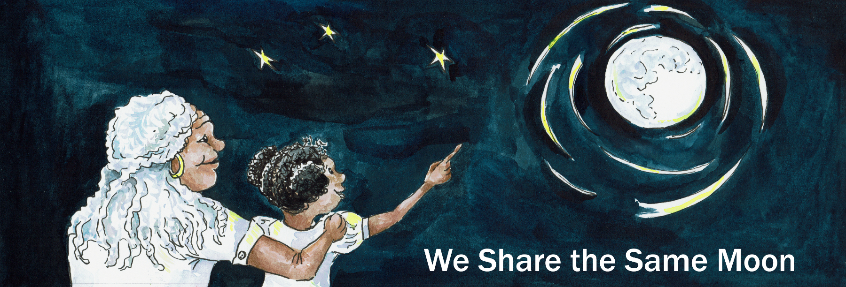Suggested Age Range: 7 - 8 years; 8 - 9 years; 9 - 10 years 10 - 11 years; Adult;

UK Curriculum: Key Stage Two (Upper);

Suggested UK Year Group: Year Five

UK Primary Curriculum Link: Forces

Science Subject: Gravity

Science Questions: Is there Gravity on the Moon?

Suggested Science Activity: Forces

Children with SEND: Use to boost comprehension of science vocabulary

EAL children: For intermediate learners

Country of Origin: Sri Lanka

Source: Unknown - heard in performance

Long ago, in the island of Sri Lanka …

There was a rich man who owned, almost all the land that is now called Sri Lanka. And he parcelled out the land into small pieces which he rented to the villagers around the island. And in return for the land, they paid him rent.

And these villagers scraped a very poor living off the land. There was just enough land, to grow just enough food, to feed their family and pay their rent.

But their landlord was a greedy man. He would sit by his money-box and count all of the golden coins paid to him by these hardworking villagers. And it always seemed to him, that there wasn’t enough. So he would increase the rent and increase the rent until there wasn’t enough money left from paying the rent to feed the people. And slowly, surely, the villagers began to starve.

One night, the rich man was tucked up in his bed, with his silk covers pulled up to his head. Fast asleep, he snored. And then suddenly, he woke up.

He had heard a very strange sound! BOOM! BOOM! BOOM! BOOM!

What could it be?

He was so scared, he didn’t even dare peek out of his curtains.

BOOM! BOOM! BOOM! BOOM!

What could it be?

He was so scared, he hid under the bed-clothes.

BOOM! BOOM! BOOM! BOOM!

He quivered with fear but he did not move until the sounds had long gone.

At day-break, he cautiously got out of bed and tip-toed to the door and peered outside.

Oh no! His precious patch of melons had ben squashed!

Oh no! His fabulous field of rice had been squished!

Oh no! His beautiful banana trees - they had been splatted to the ground!

What had happened? Robbers!

He darted outside to look for clues.

Footprints! There were lots - but they were enormous! Much bigger than human feet!

What had happened that night? And would it happen again?

And that night it did! BOOM! BOOM! BOOM! BOOM!

And the next night! BOOM! BOOM! BOOM! BOOM!

And the next! BOOM! BOOM! BOOM! BOOM!

Until there was little left that had not ben squashed, squished or splatted!

What to do?

That night, he plucked up all of his courage, (there wasn’t very much),

And he hid behind the door to his house. And he left the door ajar and peeked.

The sun began to set, the Moon began to rise …

And the house grew quiet as everyone fell asleep.

And then … BOOM! BOOM! BOOM! BOOM!

The noise was coming from the sky! The old man looked up and saw the sky was opening, there was a flash of light, a staircase emerged and down the celestial staircase came a white Elephant!

The Elephant marched down the staircase and into the garden and around he stamped BOOM! BOOM! BOOM! BOOM!

Splat! went the tomatoes! Squash! went the cucumbers! Squish! went the very last melon!

Oh no! But why was the Elephant wrecking his garden?

He was obviously a gift from the Gods, all white Elephants are.

But why had he been sent to him? What was the Elephant trying to tell him?

Of course! He smacked his forehead with relief!

It was simple! The Elephant was there to tell him not to worry about his riches down here on Earth because up in Heaven he would get so much more!

After all - everyone gets what they deserve in Heaven!

And he paused and dreamed for a while, about the riches to be found in Heaven.

But then he began to wonder: How long will I have to wait to get to Heaven?

I want to be rich now!

And he watched as the Elephant then turned and walked back up the celestial staircase and disappeared. The sky closed, the Moon shone and all was silent once more.

“Ahah!” thought the man “I know! Why wait until I am dead to go to Heaven?”

“I can follow the Elephant up the staircase to Heaven tomorrow!“

“And then I will have so much more!”

“But the staircase is too big, I will never be able to jump from stair to stair!"

“Ahah! I know I will grab hold of the Elephants tail! And he can pull me up the staircase!”

So all that day, he thought about what he would see and do in Heaven!

“Why are you looking so happy?” asked his wife. “Our garden has been ruined!”

“Oh wife, there is no need to worry about material things here on Earth.”

“Think about the life that awaits us in Heaven!”

“Heaven can wait!” She replied. “We need food today!“

"You can wait for Heaven as long as you please! But I am going to Heaven tonight!”

“How?” asked his wife.

And of course - when he told her about his plan, she decided to come too!

And then, she told her brothers and sisters, and they decided to come too!

And so that night, there was a line of people waiting to go to Heaven.

The old man couldn’t believe it! And what’s worse…

“Why have you all brought so many boxes and bags with you?”

And it seemed that none of them had wanted to leave any of their earthly treasures behind. So they had brought them all.

“Good idea!” said the rich man. And he went inside, grabbed his money-box,

strapped onto his back and wait outside.

“Now quiet!” he said. “I think the Elephant is coming!” BOOM! BOOM! BOOM! BOOM!

The Heavens opened, the staircase appeared, the Elephant walked down and past the house and …

Now! cried the old man!

He jumped and grabbed hold of the elephants tail.

His wife grabbed hold of him, her sister grabbed hold of her and one by one, a long line of people formed, each of them somehow still holding on to all their treasure, as they held onto the person in front of them.

BOOM! BOOM! BOOM! BOOM! The Elephant climbed back up the staircase.

BOOM! BOOM! BOOM! BOOM! The family swung in line behind him.

Up and up and up until…

The old man’s wife tapped him on the shoulder.

“Are you sure we will have more treasure in Heaven than on Earth?”

"Yes of course we will!” “But how much more?” ” Lots more!”

“But how much more exactly?” “Oh lots and lots more!”

"But how much more precisely?”

"Oh for goodness sake, woman! This much more!"

And the old man spread out his hands to show her how much more precisely.

And of course as he did so ….

He let go of the Elephant tail!

And they all fell down!

Down and down and down, into the squishy, squelchy mud of the rice field.

And as for their treasure ….

Gloop, it sank into the mud and was never seen again.

Everything they had, had gone.

Finally, the old man realised what the Elephant was trying to tell him…

That enough was enough!

And, through the intervention of a celestial Elephant and the laws of gravity he understood what the word “enough” really means!

And he changed his ways and shared his riches. And peace and prosperity reigned.

Copyright Cassandra Wye May 2019