The Sun

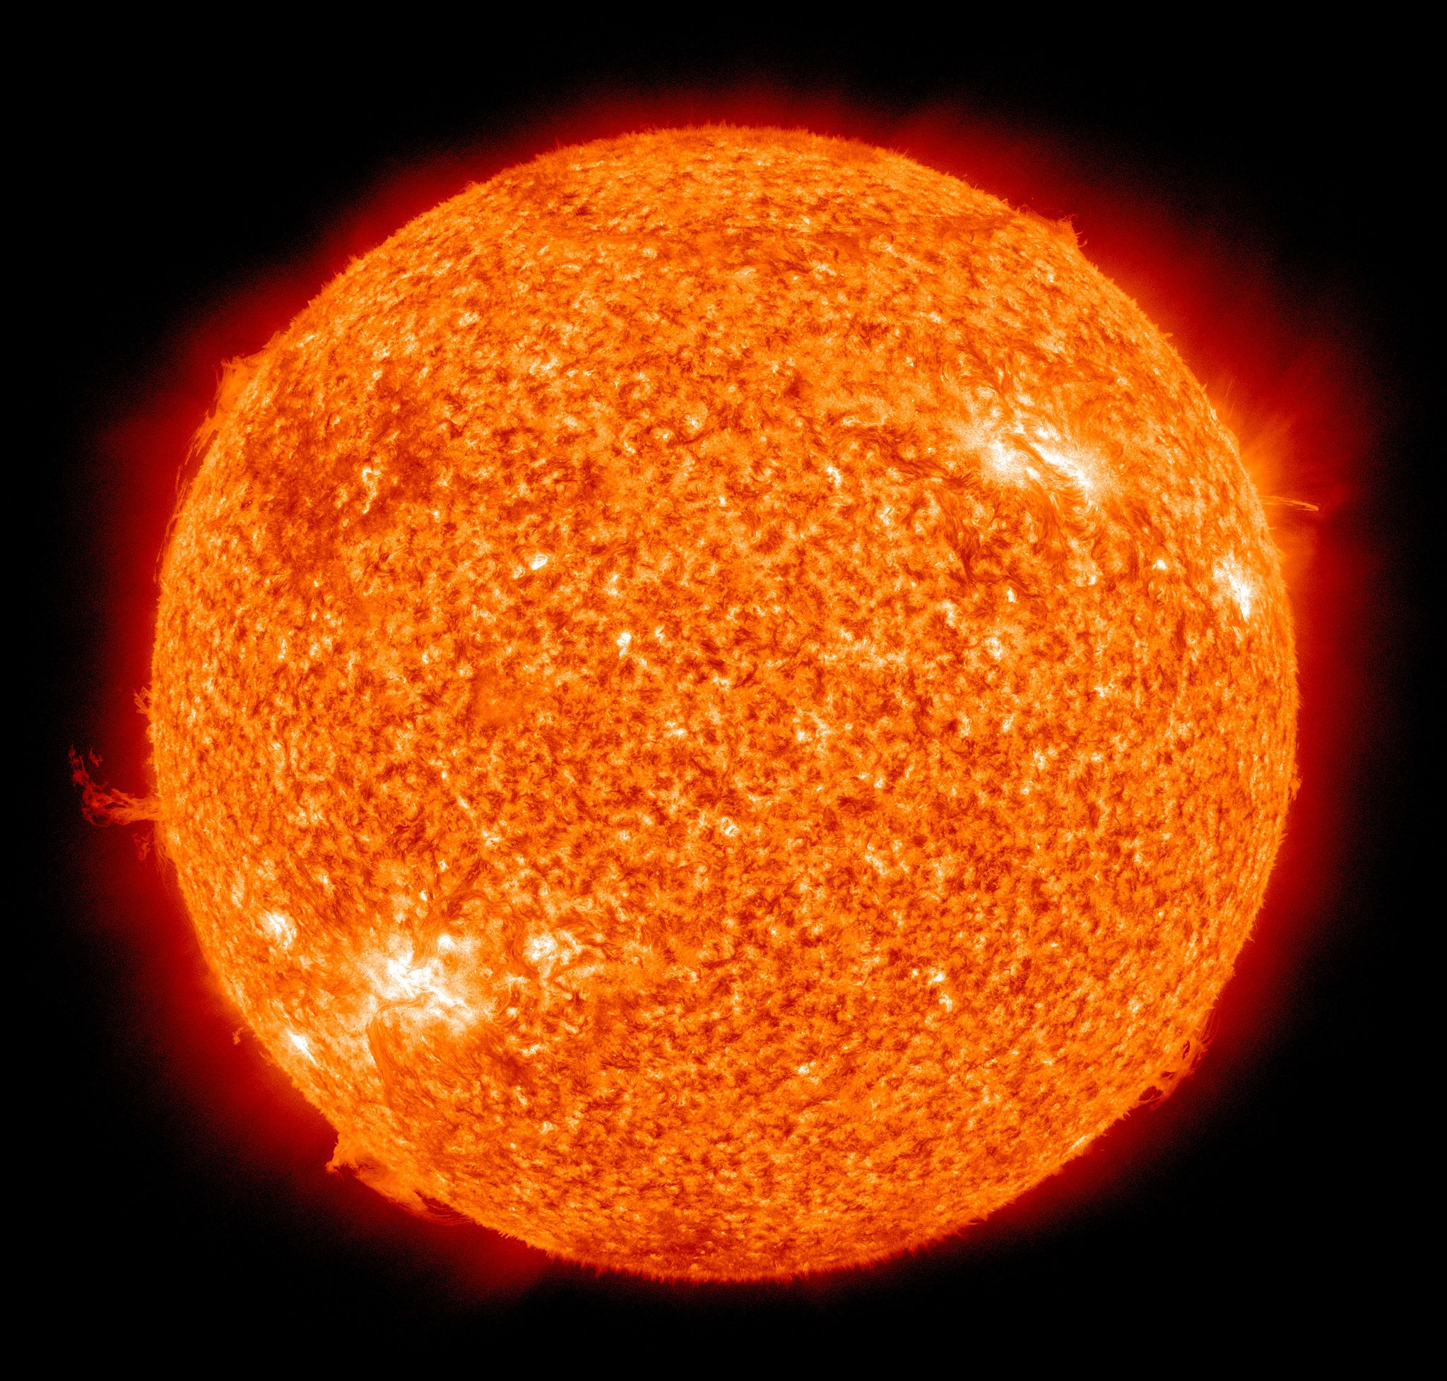
Image credit: NASA/SDO (AIA) [Public domain]

hot | yellow | gas | big
bright | round | light | heat
day | soft | orange | shiny
The Earth

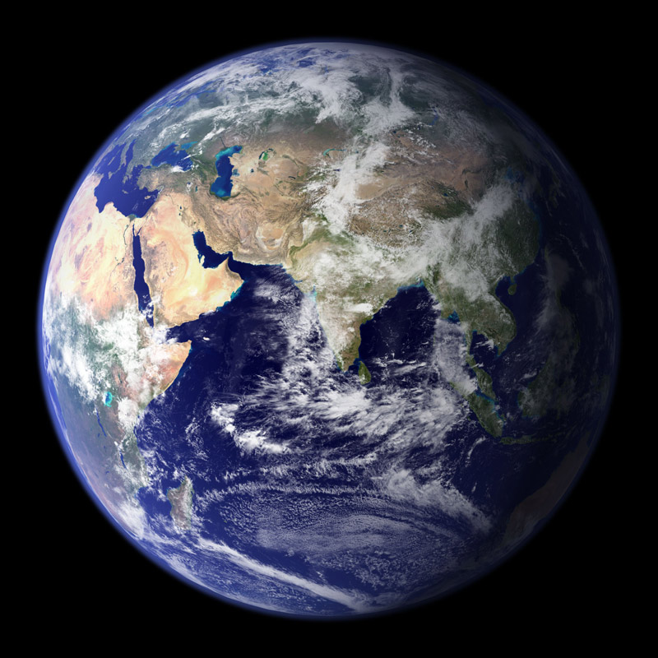
Image credit: NASA/GSFC

warm | hard | air | rock
green | round | water | clouds
earth | blue | brown | oceans

The Moon

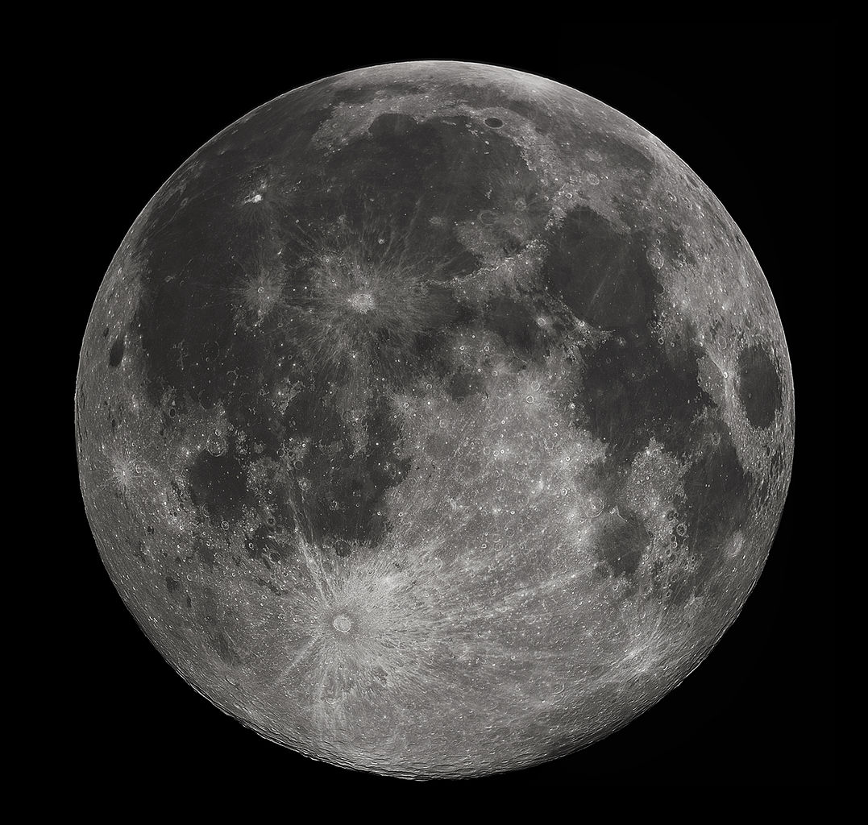
Image credit: Gregory H. Revera

cold | no air | dry | rock
grey | round | craters | ice
dust | rough | no life | hard

Mars

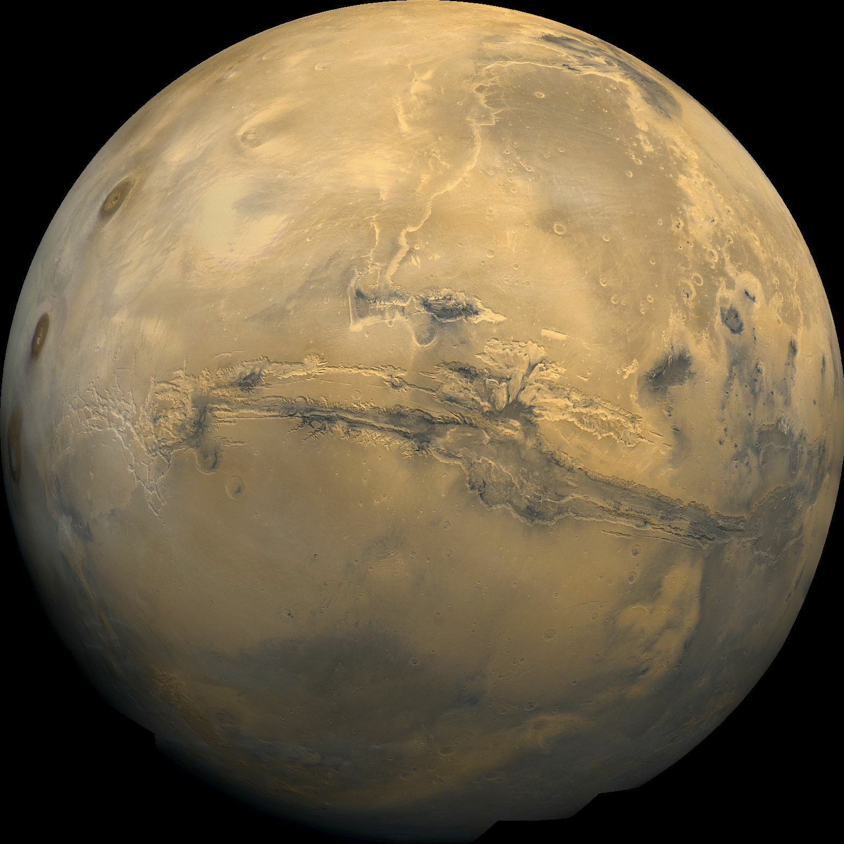Image credit: NASA/USGS

no life | no air | orange | rough
dry | round | craters | ice
dust | rock | cold | hard
Jupiter

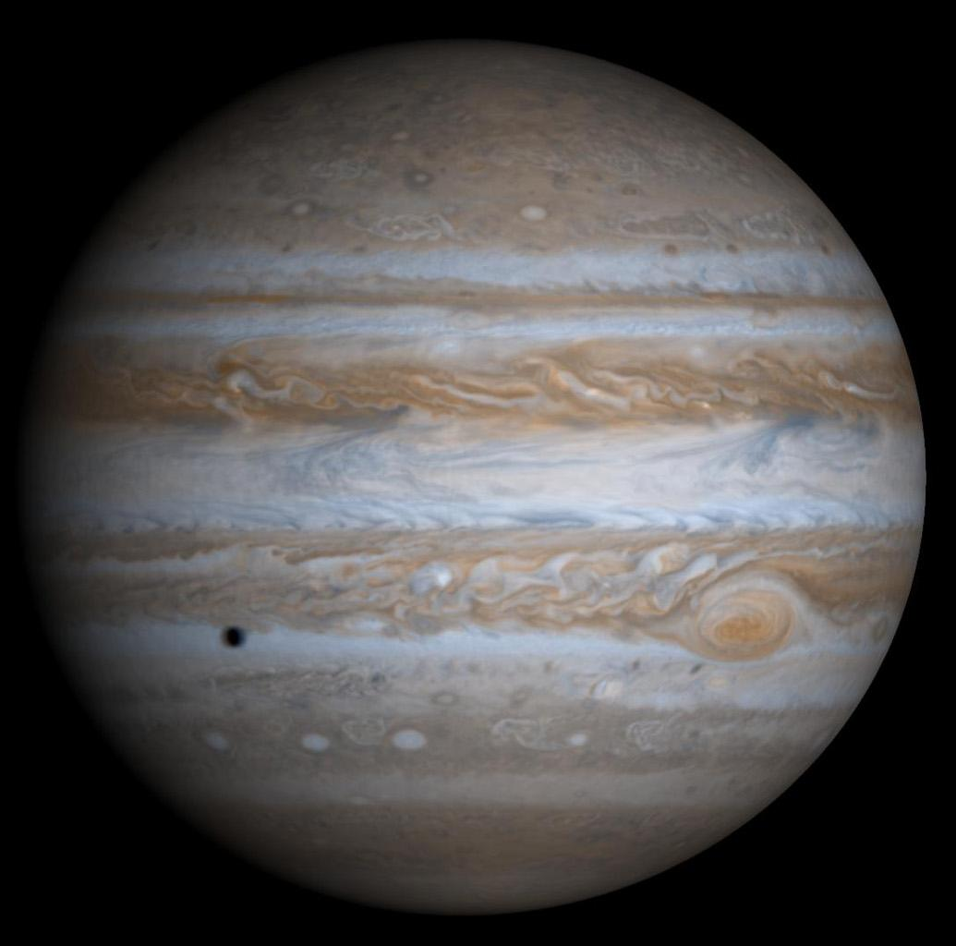
Image credit: NASA/JPL/University of Arizona

giant | gas | wind | soft
heavy | round | no life | ice
no rock | hurricanes | cold | clouds

