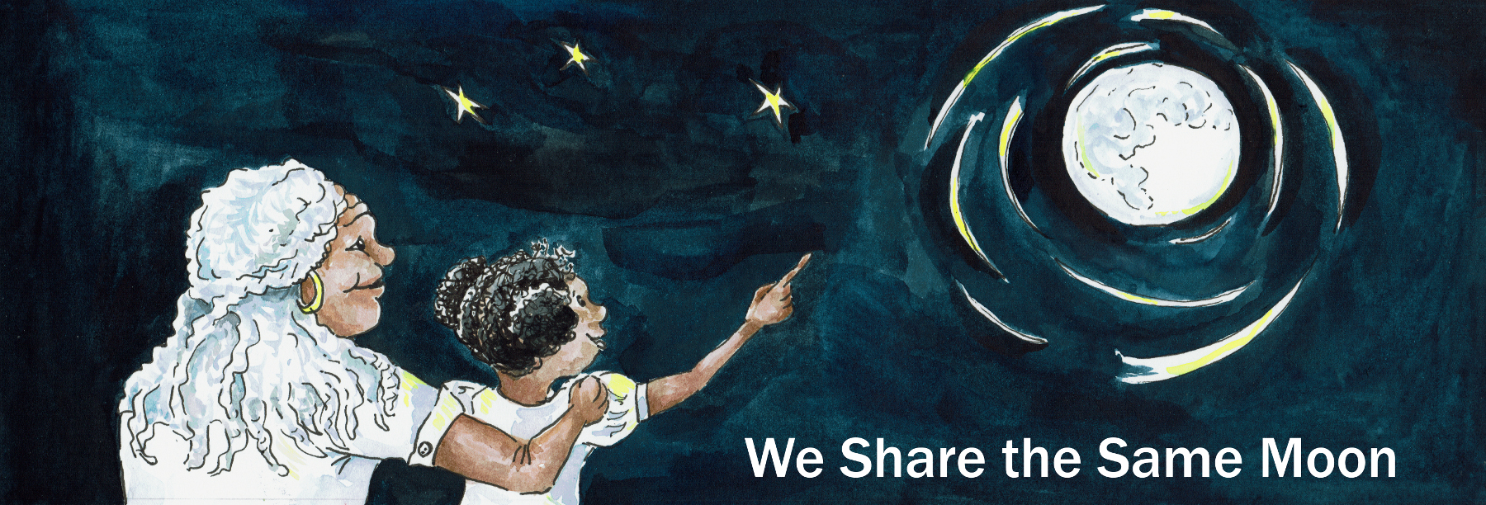

Suggested age range: 8 - 9 years
UK Primary Curriculum: Key Stage Two (lower)
Suggested UK Year Group: Year 4
UK Primary Curriculum Link: States of matter
Science Subject: The stars
Science question: Is the Sun a star? What are the stars made of?
Activity type: individual
Suggested linked story: How Coyote Created the Sun; Starlight; Dancing with the Stars; How Coyote made the Stars; The Weaving Maiden; Following the Stars to Freedom – Part One

Brief summary: The stars appear as dim points of light in the night sky, that vanish when the Sun rises. They are actually just like the Sun but are so far away that they appear very tiny and faint. Some stars are like the Sun, but some are smaller, some are larger, and they come in different colours. This activity allows students to explore the shapes and colours of stars.

Key concept: The stars are like the Sun but are much further away, and they are different colours and sizes.

Key words: star, colour (blue, yellow, red, white), shape (pointed, round)

The science story:
What do you see when you look at the sky?
The sky is blue during daytime, although sometimes it is covered in clouds and looks grey. At night we can see stars, the Moon, the planets, comets, meteors, as well as man-made things like aeroplanes and satellites.

How many stars can you see at night?
From most parts of the UK the night sky is lit by artificial light and we see a few hundred stars. In big cities like London, not many stars are visible at all. From more remote places where there are no streetlights you can see thousands of stars at night!

What are the stars? Are they made of rock?
Stars are not made of rock, they are made of gas. Stars are like the Sun, they are very big, very bright, and very, VERY hot. They look tiny and faint because they are so far away.

What colour is the Sun?
To most people, the Sun looks yellow or yellow-white.

What colour are the stars?
Just like people, stars come in many forms. Stars come in different colours. If you look closely you will see that some stars are yellow, like the Sun, but some are blue, and some are red.

Stars are also different sizes. Some stars are small, some stars are very big. Our Sun is quite a small star.

Stars are also different shapes – what shape are stars? Can anyone draw me a star?
(Let the students draw what shape they think of as “star-shaped” on a flip chart or white board.)
Stars are often drawn as pointy shapes. Sometimes they have four points, sometimes they have five points, sometimes they have six points, sometimes they have twenty points!

Are stars really pointy? What do you think?
Stars are actually round, not pointy. They are in fact just like the Sun, but they are so far away that they look much less bright. We see them as pointy shapes for two reasons.

The first reason is that the light from a star has to come through the air to reach us, The air makes the light dance around, so that stars look like the twinkle.
The second reason if that our eyes are not perfect. The bit at the front of your eye is called the lens, that’s where the light comes in. As you get older, your lens gets scratched by dust and sand that is blown around in the wind. The more scratches on your lens, the more pointy the stars look, so the spikes get more prominent as people age (especially if they live somewhere with a lot of sand)!

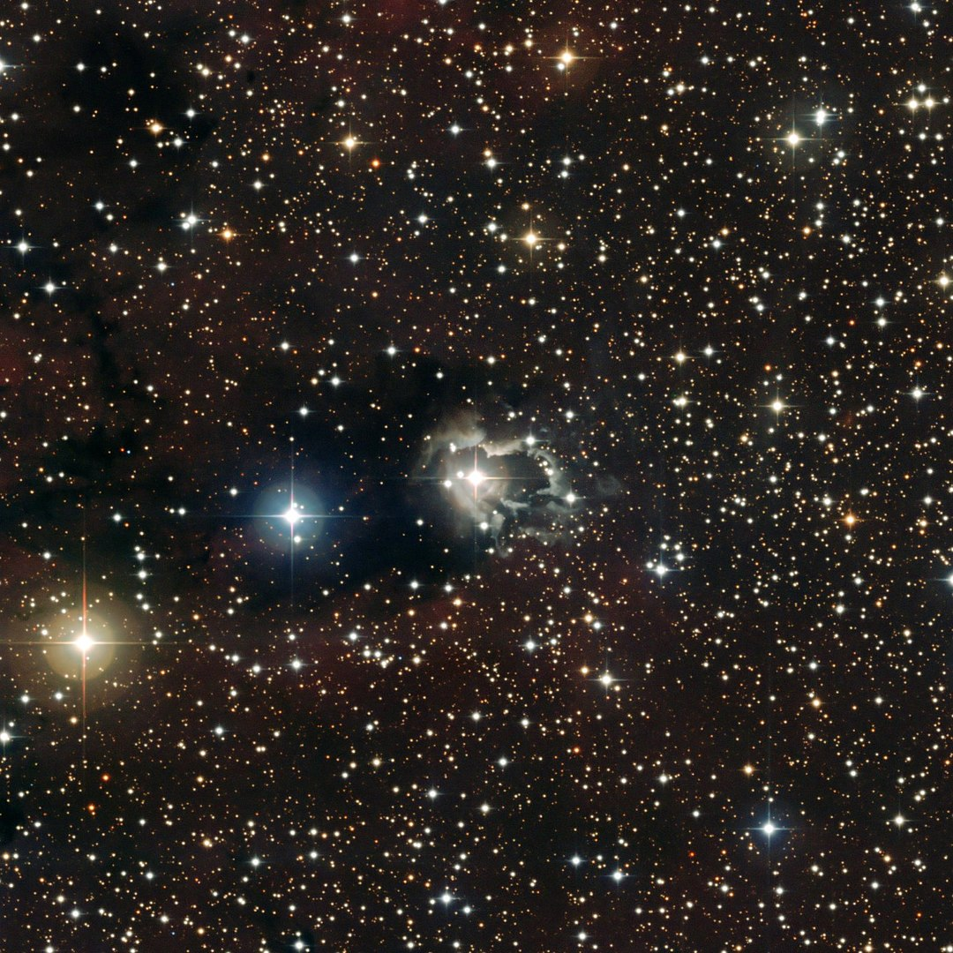
Above: A photograph of part of the sky showing how stars can look different colours.
By ESO - http://www.eso.org/gallery/v/ESOPIA/Stars/phot-28a-09-fullres.tif.html, CC BY 3.0, https://commons.wikimedia.org/w/index.php?curid=7649480
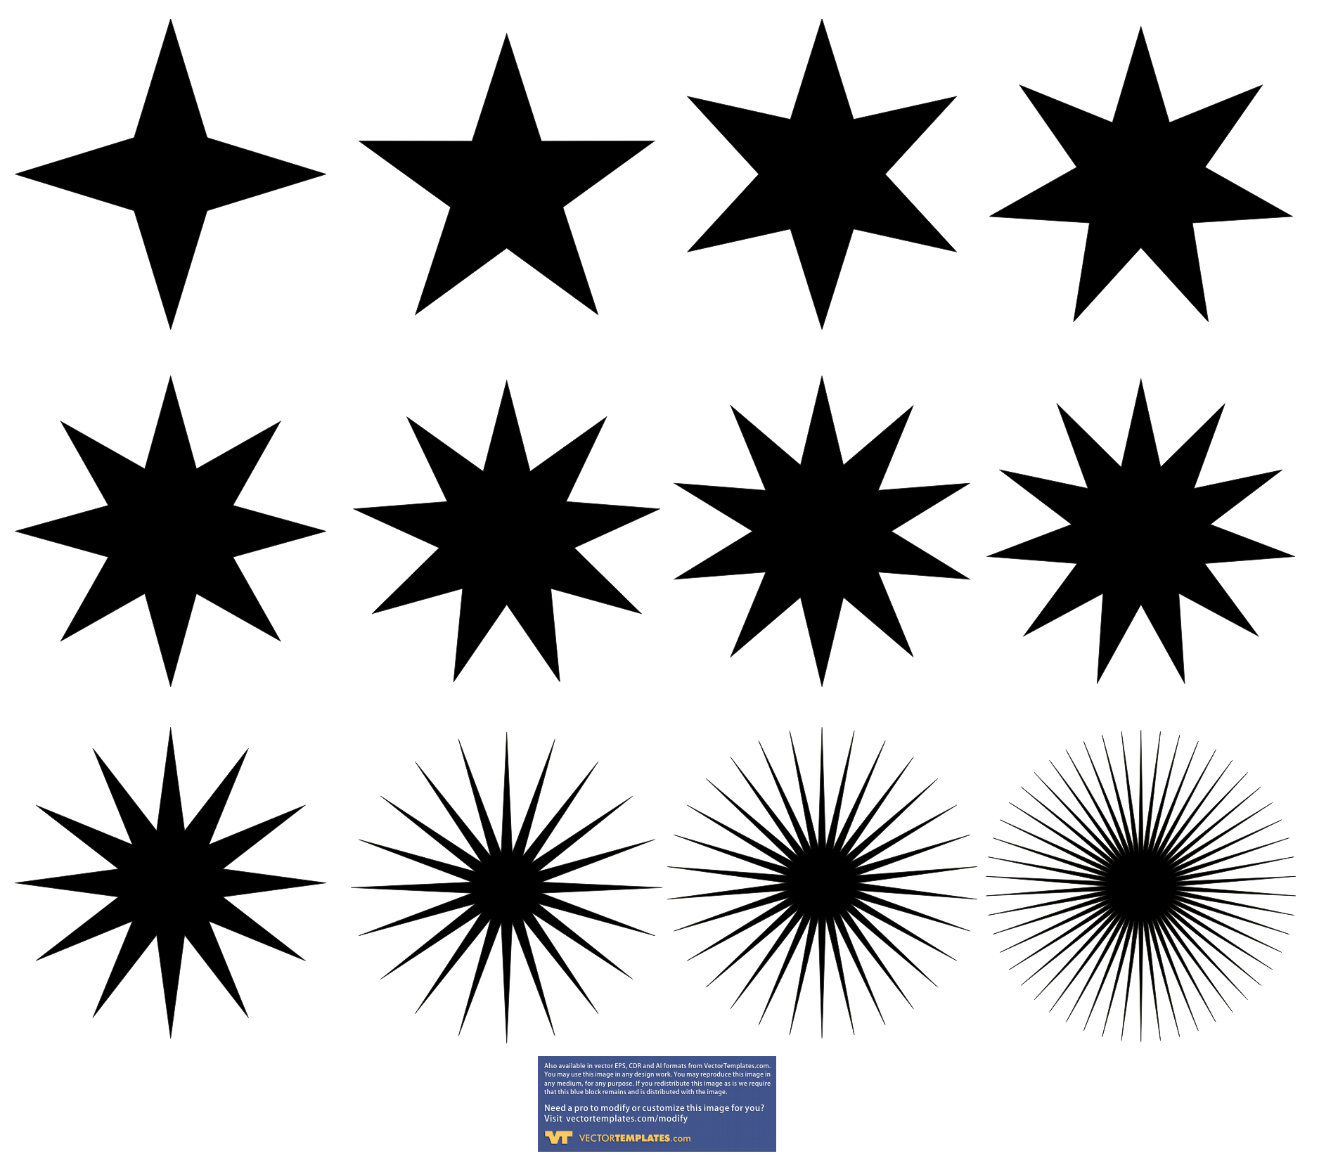
Above: Different types of star shapes
The science: Stars, like the Sun, are giant nuclear reactors. Stars are giant spherical balls of gas, mostly made of hydrogen. Deep in the centre, at extremely high temperatures, stars are fusing hydrogen and making helium. This process generates all of the heat and light that comes from stars, including our Sun.

The Sun is about 6000 degrees Celsius on the surface and is yellow in colour. The colour of a star is related to its surface temperature; hot stars can be more than 10,000 degrees on the surface and look blue in colour, cool stars are roughly 3,000 degrees on the surface and appear red in colour. This colour variation is the opposite way around to the taps in a bathroom – the hot tap is red, while the cold tap is blue!

Star also come in different sizes. Cooler, red stars are generally very small compared to the Sun, and are often very faint. Bluer, hotter stars are much larger than the Sun in size and can be many thousands of times brighter than the Sun.

On the sky, the brightness of a star depends on how bright the star is, but also how close it is – some stars are nearby, others are much further away.

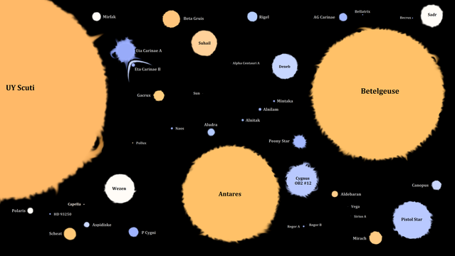
Above: Some well-known stars with their apparent colours and sizes.
By GiovanniMartin16 - Own work, CC BY-SA 4.0, https://commons.wikimedia.org/w/index.php?curid=64792989

The activity: The aim of this activity is to create hats that show stars of different sizes and colours. The students can choose to make their stars realistic (round) or more stylised (spiky).

Props required:
- Thin card, cut into strips about 10cm wide and ~70cm long
- Coloured card (red, yellow and blue) cut into squares
- Scissors
- Pens, crayons, colouring pencils or paints.

Safety note: Care needs to be taken when using scissors. Additional adult supervision is recommended.

Safety note: When stapling together the head bands, take care that the sharp ends of the staples end up between the two halves of the cardboard.

- You are going to make a star crown to wear! Collect some squares of coloured card – these will become your stars.
- Decide what sort of shapes and colours you want your stars to be.
- Draw the shape of your stars on to the coloured squares.
- Carefully cut out your stars. Ask an adult for help if you need it!
- Take a strip of card and fold it in half along the long edge.
- Put the stars on your headband and attach them with tape.
- Ask an adult to staple the crown together for you.
- Put the crown on your head and show your friends how creative you are!

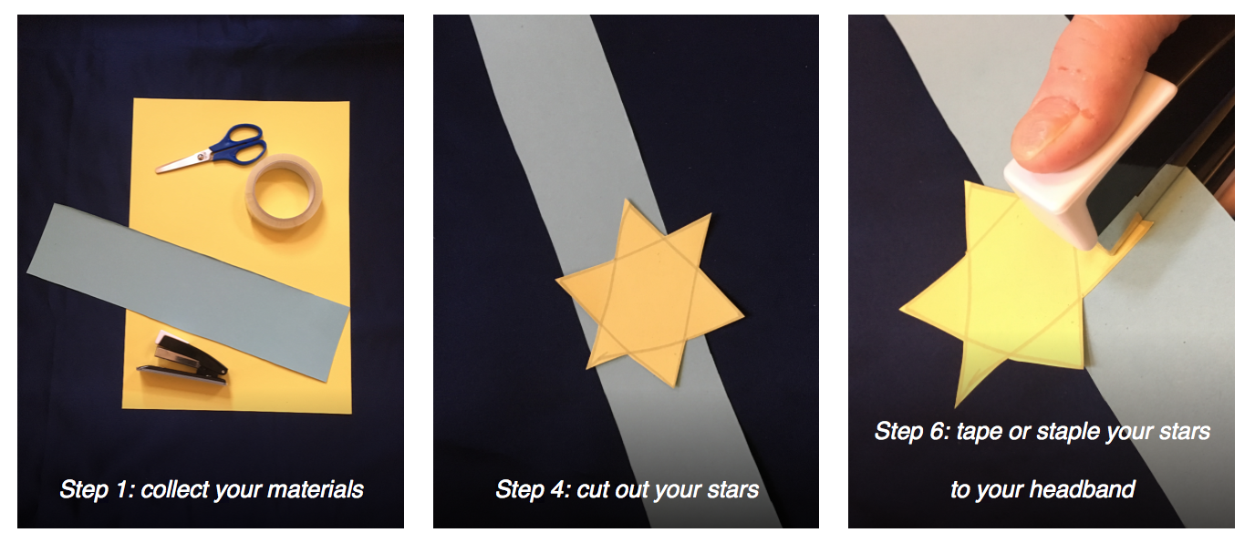
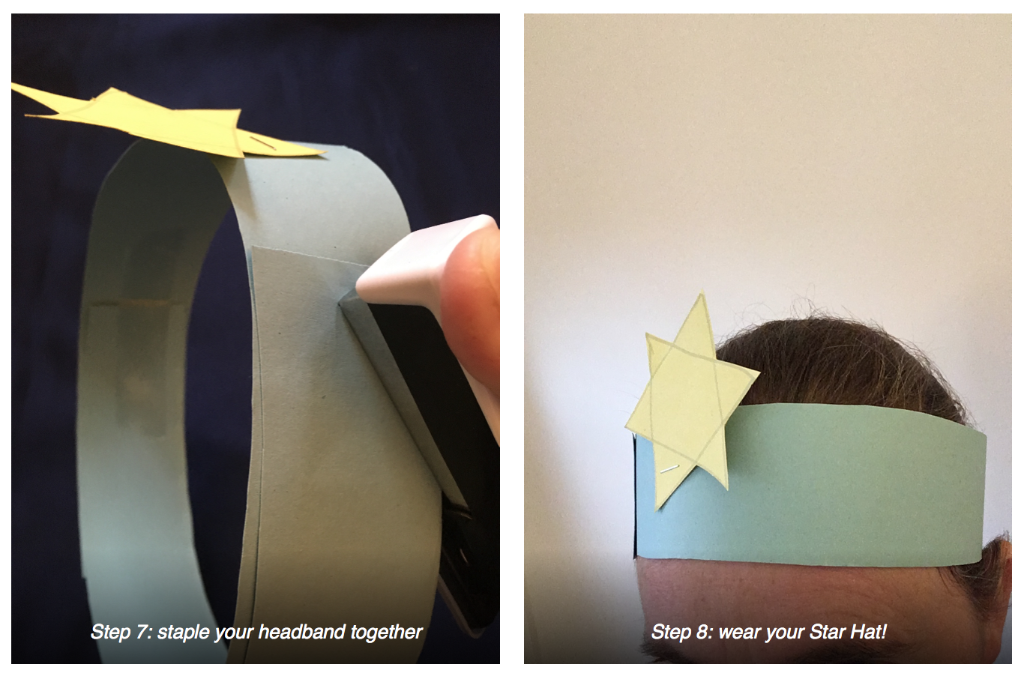

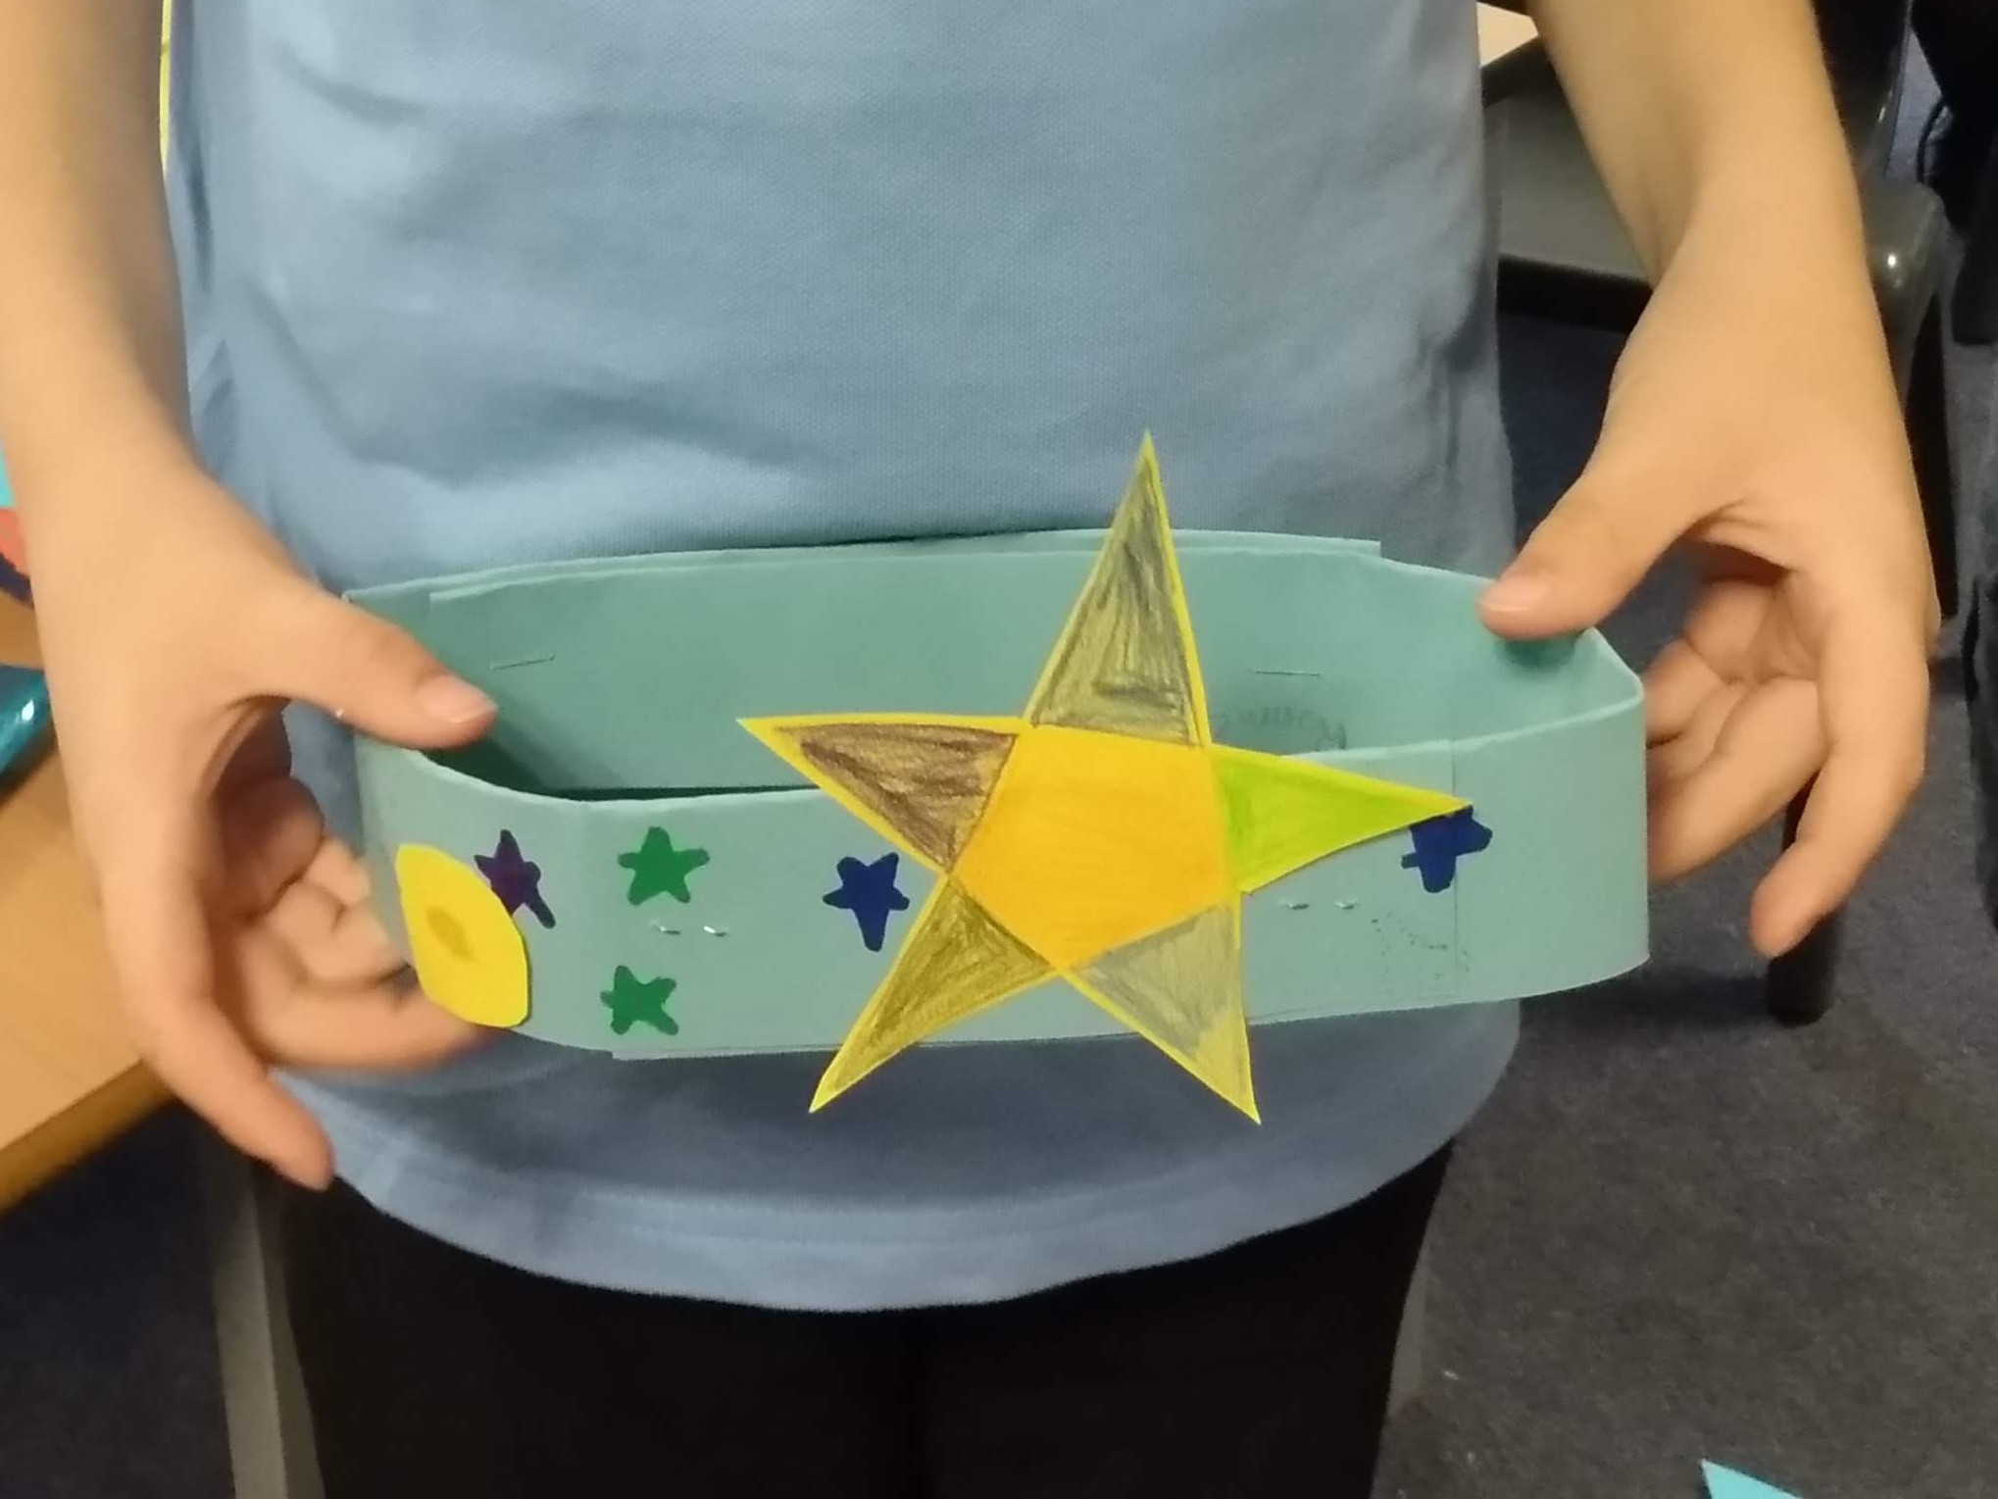
Above: an example Star Crown made by a student at Castle Primary School
Extension: This activity can be extended by asking the students to make extra stars, and then either hanging them from a mobile or from the classroom ceiling using threads of different lengths. You can then introduce the idea of constellations by seeing if the students can see any patterns.

If you are using any of the American Indian star stories, such as How Coyote Made the Stars, you might like to show the image below to show the American Indian constellations on the sky.

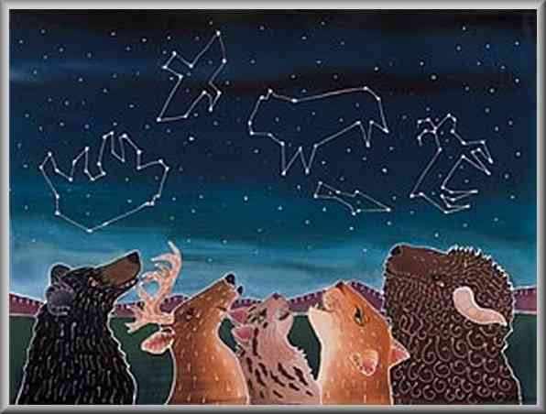
Illustration of animals and their constellations in the sky. Image source: http://www2.needham.k12.ma.us/eliot/technology/lessons/na_star_stories/index.html

Common misconceptions:
- A common misconception is that brighter stars are closer than faint stars. This misconception can be dispelled by using an analogy of looking at a candle in the same room, and then imagining trying to see the same candle on a distant mountaintop.
- Stars are usually drawn with spikes, such as on Christmas cards. Stars do not really have spikes, they are actually spheres of gas. The spikes that we see are often due to having a scratched cornea, so the spikes get more prominent as people age (especially if they live somewhere with a lot of sand). Another explanation of this phenomenon: http://curious.astro.cornell.edu/about-us/111-observational-astronomy/stargazing/general-questions/674-why-do-people-draw-stars-with-five-points-intermediate

Use with other years:
- Maths (KS1) – this activity works well with KS1 year groups to explore the different shapes of stars (4, 5, 6 points etc). This can be used either to test existing knowledge or to introduce new concepts.
- You can add more explanation if needed, for example by showing the students how to draw a star: https://www.wikihow.com/Draw-a-Star

Curriculum links:
- Science KS2 (lower) States of matter – the stars are made of material that is very hot, and exists as gas.
- Science KS2 (lower) Light – light from the Sun can be dangerous and that there are ways to protect the eyes (but only because we are so close to it!).
- Geography KS2 – you can explore the cultural relevance of stars – the star of Bethlehem, stars that appear on national flags, etc.

Copyright: Megan Argo 2019

