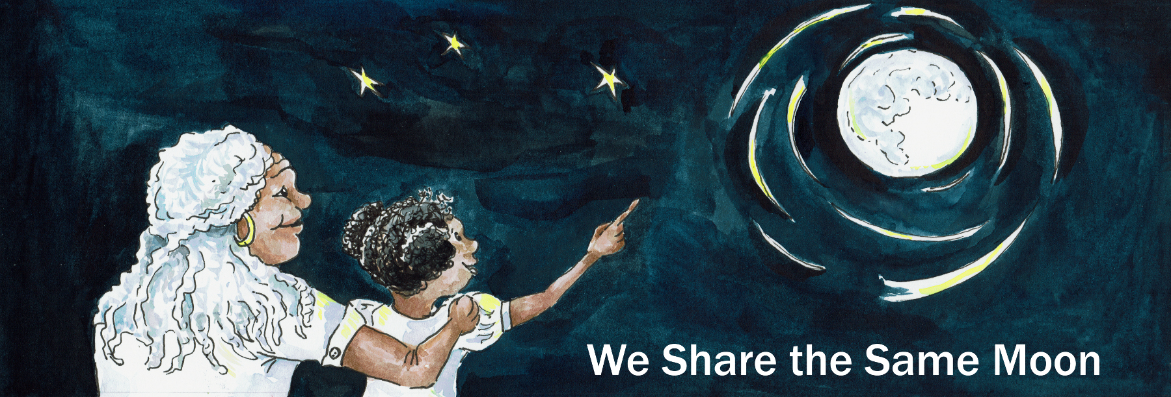

Suggested Age Range: 7 – 8 years
UK Primary Curriculum: Key Star Two (lower)
Suggested UK Year Group: Year 3
UK Primary Curriculum Link: Rocks
Science Subject: Space rocks; Meteors, asteroids and comets
Science question: What are comets? What are meteors? What are asteroids?
Activity type: small groups
Suggested linked story: Dancing with the Stars, The Storytelling Stone

Brief summary: There are many different types of space rocks. Our Solar System contains the Sun, the eight planets, as well as numerous dwarf planets, many rocky asteroids, comets and meteoroids. Comets have often featured in historical accounts as portents of doom or disaster (one features in the Bayeux Tapestry, for example), but the reality is that they are giant dirty snowballs. As they get close to the Sun they begin to warm, and some of the ice begins to turn to gas, creating the spectacular tails visible from Earth. This activity helps students to understand what comets are made of, and why they look the way they do in the sky.

Key concept: Comets are made of ice, dust, rock, and traces of simple organic materials. Asteroids are made of rock. Meteors are small rocks or dust fall into our atmosphere and are often known as shooting stars.

Key words: comet, asteroid, meteor, dust, ice, space rock

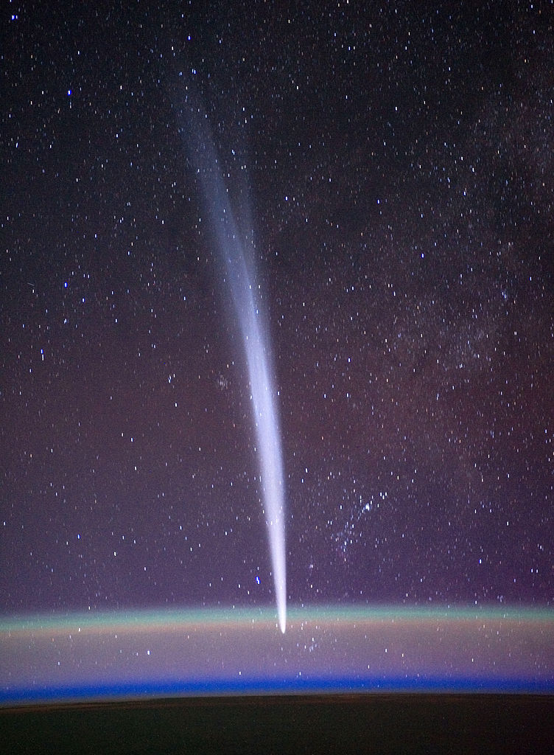
Left: a photograph of Comet Lovejoy, as seen from the International Space Station, orbiting roughly 200 kilometres above the surface of the Earth. The comet is seen against a background of stars. The dark area at the bottom of the photograph is the surface of the Earth. The fuzzy green line is a phenomenon known as air glow. Between the ground and the green air glow lies our atmosphere. The comet is a long way from the Earth and so, although it looks as though it is heading into the atmosphere, it is actually in the background.
Image credit: NASA/Dan Burbank

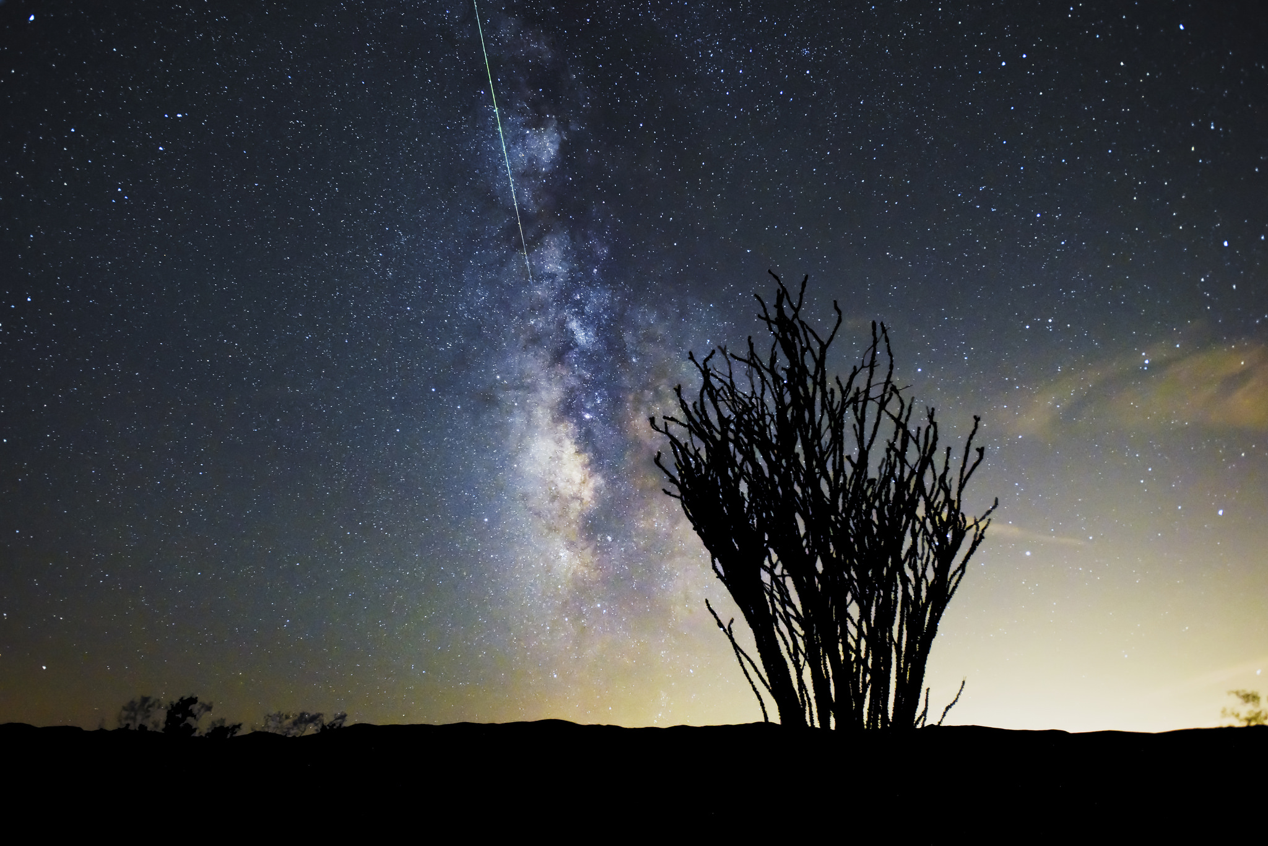
Above: This is a photograph of a meteor or shooting star. These look different to comets – they are much thinner, and they move much faster. Comets can stay in the sky for many weeks, whereas meteorites pass through the atmosphere in less than a second.
Image source: https://www.flickr.com/photos/joshuatreenp/20713070995/in/album-72157651261832459/

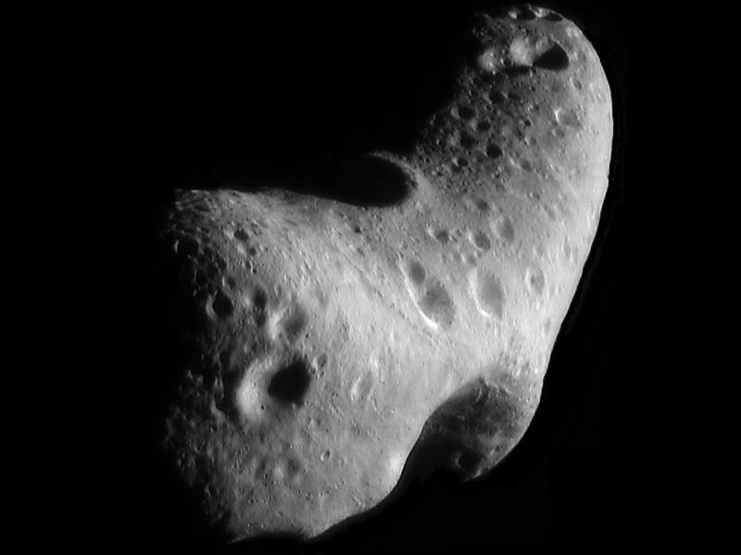
Above: This image, taken by NASA’s Near Earth Asteroid Rendezvous mission in the year 2000, shows a close-up view of Eros, an asteroid with an orbit that takes it somewhat close to Earth. NASA’s Spitzer Space Telescope observed Eros and dozens of other near-Earth asteroids as part of a survey to study their sizes and compositions.
Image source: https://www.nasa.gov/mission_pages/spitzer/multimedia/eros.html

The science story:
Apart from stars and planets, we find rocks in space. Can you name any types of space rocks?
Types of space rocks are meteors, comets, and asteroids. They are all made of the bits that were left over when the planets of our Solar System formed four and a half billion years ago.

What is an asteroid?
An asteroid is a large space rock. Some are small, only about the size of a car, some are larger than a whole country! There are many asteroids in the Solar System. Lots of them orbit the Sun between the planets Mars and Jupiter, but they can be found all over the Solar System.

Has anyone ever seen a comet? What does a comet look like?
Comets are fuzzy blobs in the sky, a comet looks like a tiny cloud when you look at it through a telescope. Sometimes they have tails (illustrate with a photograph, see above) that can stretch across the sky, some comets look spectacular! They only look like this when they get close to the Sun though.

What do you think comets are made of?
Comets are made of ice, dust, and smalls bits of rock, all mashed together to make a giant dirty snowball. Imagine a snowball as big as a city! Far away from the Sun it is very cold, so comets stay frozen, just like ice cream does in the freezer.

But if a comet is unlucky and comes close to the Sun, what happens?
If a comet gets too close to the Sun it begins to melt, just like a snowman in the spring. As it melts some of the ice and dust gets left behind as it travels around the Sun, and those bits that are left behind are what makes the spectacular tails. When the Earth passes through these tails, some of the rocks fall though the atmosphere and hit the ground – these are known as meteorites.

Has anyone ever seen a meteor?
Meteors are what we call these little bits of rock when they fall through our atmosphere. They are also called shooting stars, as in the story Dancing with the Stars. But meteors are not really stars, stars are made of gas, but meteors are made of rock.

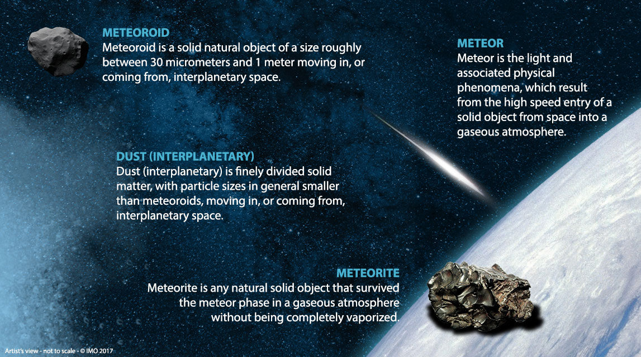
Above: An artist’s illustration (not to scale) of the journey of a small space rock from space to the Earth’s surface. The same rock is given different names by scientists depending on where it is. This rock is called a meteoroid when it is in space, a meteor when it is passing through the atmosphere, and a meteorite when it lands on the ground. Image credit: http://www.imo.net/

The science:
Comets are made of the material left over from the formation of our Solar System, roughly 4.5 billion years ago. They mostly consist of ice, dust, rocks of various sizes, and traces of organic compounds. There is a lot of scientific interest in studying comets because they formed so long ago, the hope is that by studying their chemistry we can better understand the formation of the Solar System and test models of how the Solar System has evolved over the last 4.5 billion years. Comets spend the majority of their time in the outer Solar System where it is very cold, many thousands of times further from the Sun than the Earth.

Unlike planets, comets do not move in circular orbits around the Sun, instead they travel in very elongated elliptical orbits. These elliptical orbits mean that, from time to time, one of them comes close to the Sun. As a comet moves closer to the Sun, the temperature rises and the ice on the surface starts to sublimate – it passes from a solid to a gas without passing through the liquid state (this can happen at low pressures such as those in the near-vacuum of space). As the water turns to vapour, it can take some of the dust and rock with it. This forms a cloud around the comet nucleus, known as a coma – this is what makes comets appear fuzzy through binoculars or a telescope.

The comet keeps moving in its orbit while this process happens, and as it does so it leaves behind a debris trail of gas, dust and small rocks behind it. The bits of rocky debris that are left behind are called meteoroids – when the Earth passes through this left-behind debris, the bits of rock fall into the Earth’s atmosphere and become meteors. When they land on the surface of the Earth, we call them meteorites.

The Sun is continuously shining, but it is also producing a constant “wind” of particles and gas moving out through the Solar System at hundreds of kilometres per second. This wind pushes the material in the debris trail of the comet, just like a hairdryer would blow away the steam from a pan of boiling water. The consequence of this is that the tail of a comet always points directly away from the Sun.

The activity:
This is best done in small groups. Supervision is recommended as it can get messy, and it is best to use ice straight from the freezer if you can (warmer ice does not work as well). If you have access to liquid nitrogen, this works really well for this activity, freezes the comets much faster, and is a bit of a “wow” factor, but MUST be done by an adult with appropriate safety equipment.

Props required:
- Large resealable food bags
- Small resealable food bags
- Lots of ice
- Whole milk (low-fat versions do not work as well)
- Cookies, crushed (for the dust)
- Chocolate chips (for the rocks)
- Vanilla essence (for the organic material)
- Gloves for handling the ice
- Small paper cups and spoons for eating the comets!

Safety note: It may be necessary to substitute some items in this activity in case of allergies, intolerances or dietary requirements of anyone participating. Dairy-and gluten-free alternatives are available. Check the ingredients carefully.

- You are going to make a model of a comet - unlike real comets, this one will be good enough to eat! First you need to collect your ingredients (see above).
- Place about 100ml of milk in the small sandwich bag – this is the ice that makes up the main part of a comet body.
- Break up your cookie and add it to the milk. The cookie pieces represent the dust and loose rocks in the comet.
- Add the chocolate chips to represent the rocks.
- Add a couple of drops of vanilla essence to represent the organic materials.
- Ensure the small bag is sealed shut, and give it a bit of a shake to mix the ingredients.
- One person in your group should put on the gloves and put lots of ice in the large bag, the more the better but leave some space for the comet.
- Place the comet bag inside the bag with the ice and shake it a bit. Keep it moving so that all the milk starts to turn to ice.
- When the milk has started to freeze, remove the smaller bag and discard the ice somewhere safe. Spoon the comet into the cups and enjoy!

Extension:
This activity can be extended by making edible asteroids such as in this activity: https://www.lpi.usra.edu/education/space_days/activities/spaceRocks/makeAtHome.pdf and doing a “compare and contrast” exercise, looking at the similarities and differences between comets and asteroids.

Common misconceptions:
- Comets are often confused with shooting stars (also known as meteors). Comets are long-lived objects that can be visible in the night sky for many weeks when near to the Sun, meteors are small bits of rocks that are only visible very briefly (typically for less than a second) as they burn up in our own atmosphere.
- “Organic compounds” means there is life – organic compounds do not automatically mean that there is life, an organic compound is just a compound that contains the element carbon.
- Comet tails always show you which direction the comet came from – the tails are made up of material that is so light that the solar wind is strong enough to push it around. As a result of this, comet tails always point directly away from the Sun.

Curriculum links:
- Rocks KS2 (lower) – can be used in conjunction with an activity comparing the characteristics of different rocks and/or looking at different meteorites.
- Light KS2 (lower) – notice that light is reflected from surfaces, we see comet tails because light from the Sun reflects from the particles of ice and rock.
- States of matter KS2 (lower) – observe that some materials change state when heated or cooled.
- Earth and space KS2 (upper) – describe the movements of objects in the Solar System.
- Forces KS2 (upper) – gravity keeps the planets (and comets) in orbit around the Sun, and the solar wind produces a force that creates comet tails.

Linked activities:
Comet Tails, a non-food-based approach to understanding comets – We Share the Same Moon
https://www.wesharethesamemoon.org/?p=1297

Cosmic Craters, to explore how impact damage to planets or asteroids creates craters and produces new meteoroids – We Share the Same Moon
https://www.wesharethesamemoon.org/?p=240

A version of the non-food comet tails activity from NASA.
https://spaceplace.nasa.gov/comet-stick/en/

A more complex version of the edible comet activity from NASA.
https://www.nasa.gov/sites/default/files/546138main_ESS8_Eat-A-Comet_C2.pdf

Other resources:
STFC’s Borrow the Moon – samples of real space rock which can be borrowed and used in school (very popular so book well in advance).
https://stfc.ukri.org/public-engagement/activities-for-schools/borrow-the-moon/

What is the difference between meteors, comets and asteroids?
https://www.lpi.usra.edu/education/skytellers/meteors/

What is a meteor shower?
https://spaceplace.nasa.gov/meteor-shower/en/

Have you found a meteorite? How to identify a rock from space.
https://geology.com/meteorites/meteorite-identification.shtml

Definitions of terms in meteor astronomy.
https://www.imo.net/definitions-of-terms-in-meteor-astronomy-iau/

Copyright: Megan Argo 2019

