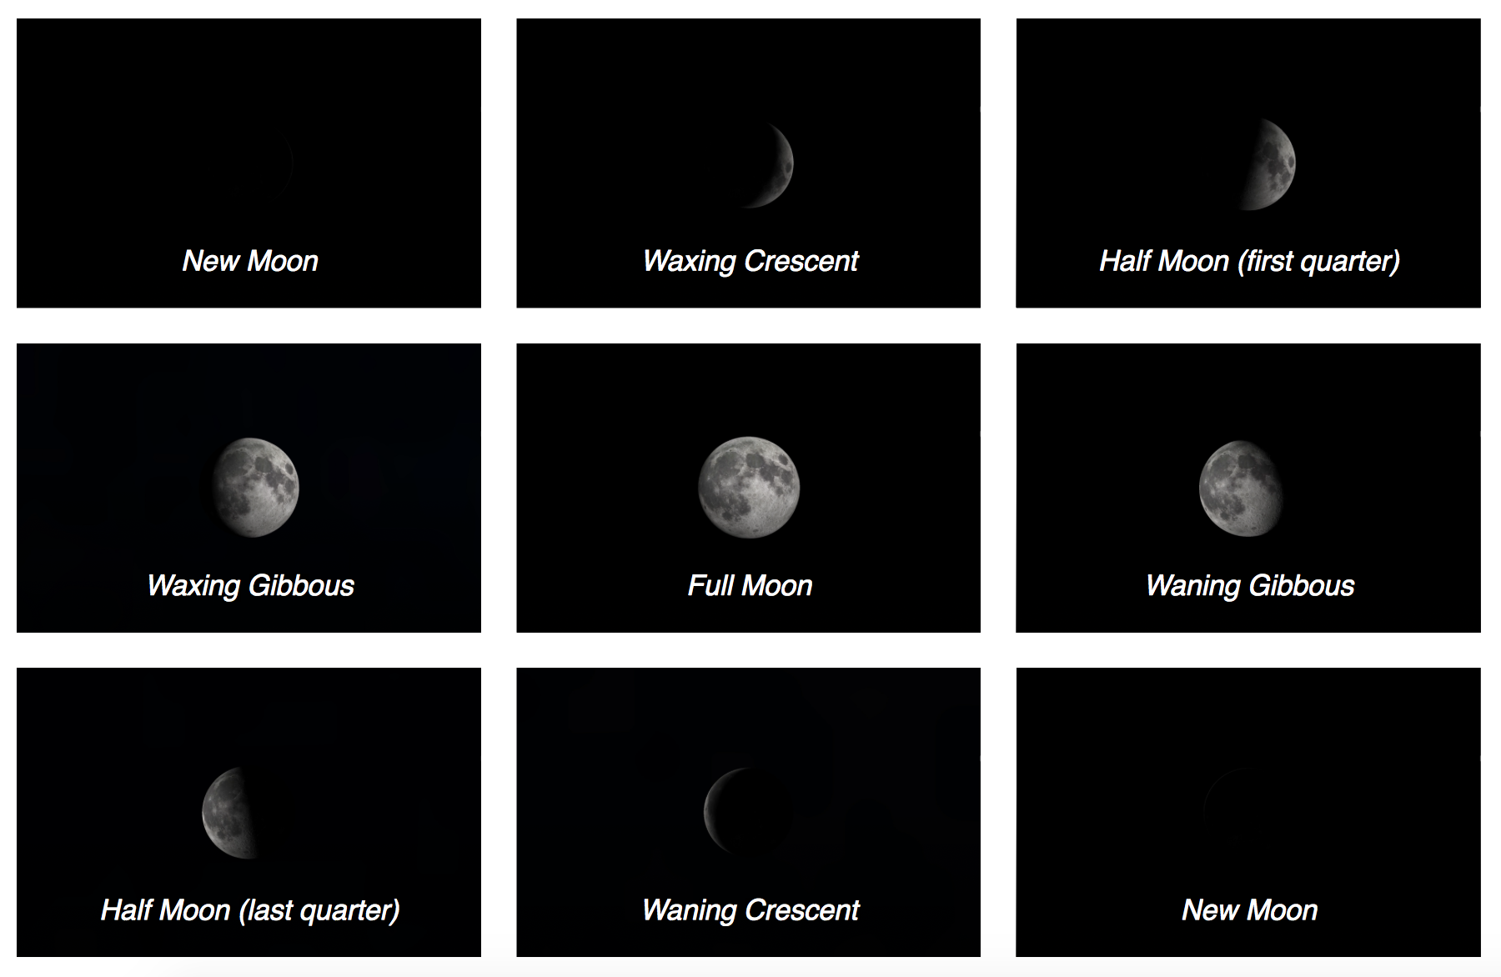

The above chart shows how the Moon changes shape over a month.

Starting with a New Moon, the Moon becomes a waxing crescent, a half Moon (also known as a first quarter Moon), then a waxing gibbous (a fancy word for more than half, but less than full), then to a Full Moon.

After that it goes through the same shapes, but in reverse, and with the shadow on the right side of the Moon instead of the left.

From Full Moon, it becomes a waning gibbous, a half Moon (also known as a last quarter Moon), a waning crescent, and back to where we started: a New Moon where the Moon is almost invisible.

The cycle then repeats from the start.

Copyright: Megan Argo 2019. Made using Stellarium.

New Moon | 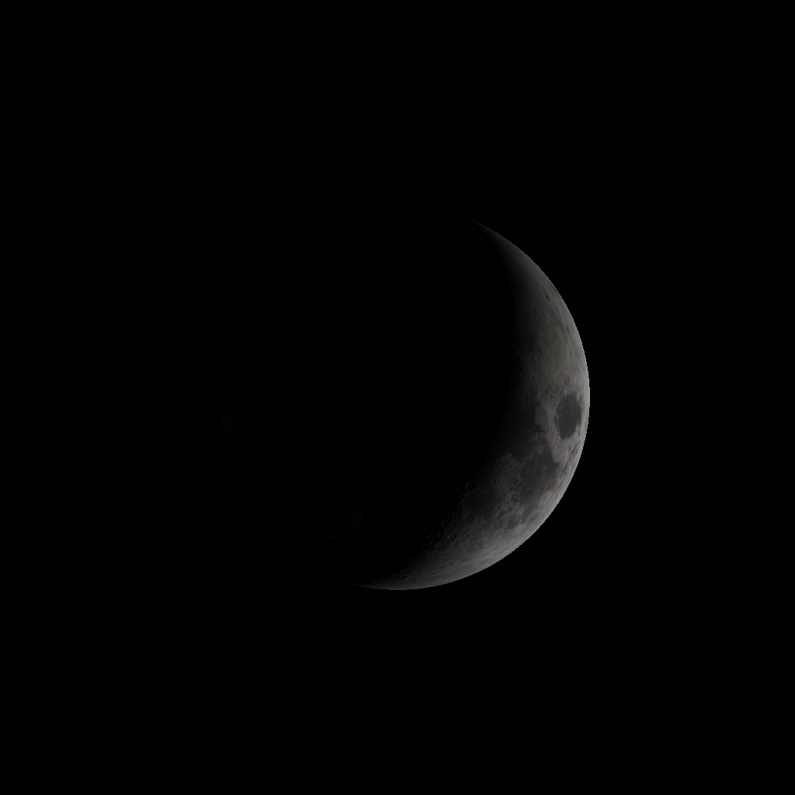  Waxing Crescent | 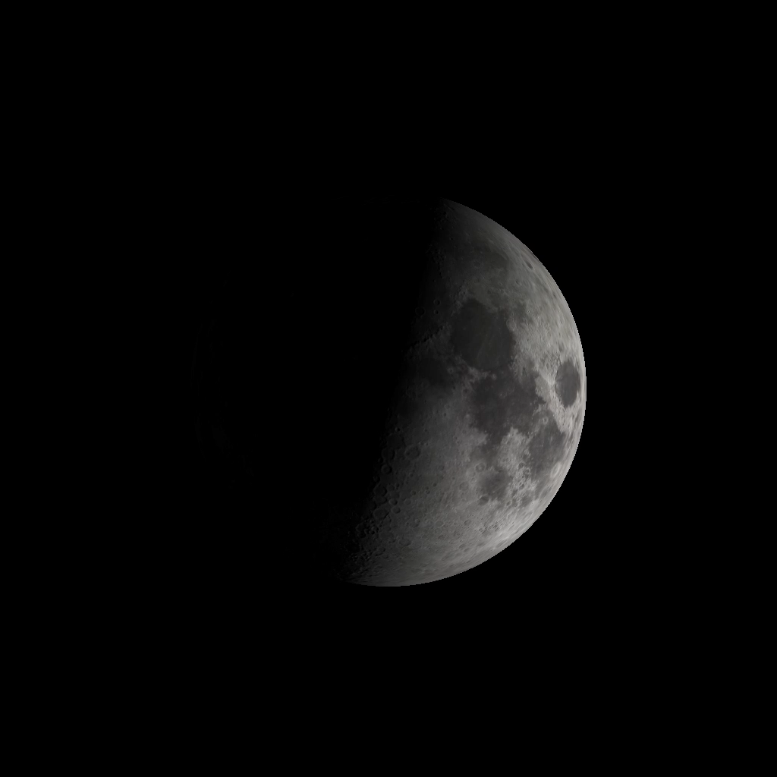  Half Moon  (first quarter)
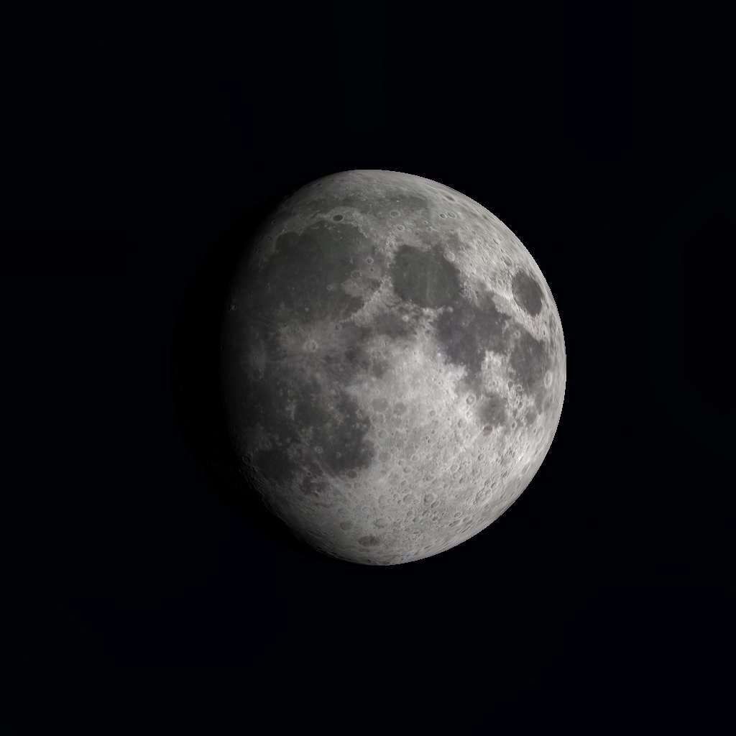  Waxing Gibbous | 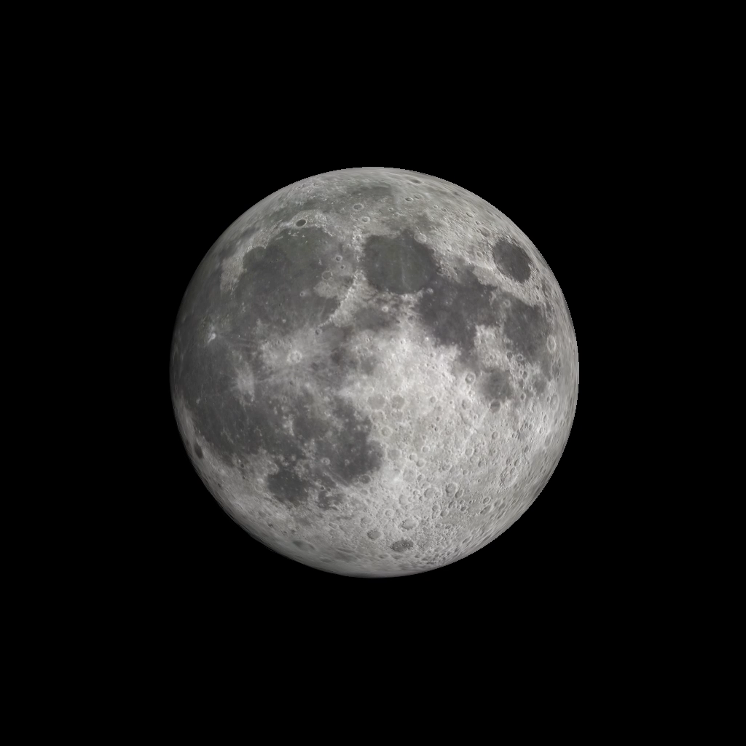  Full Moon | 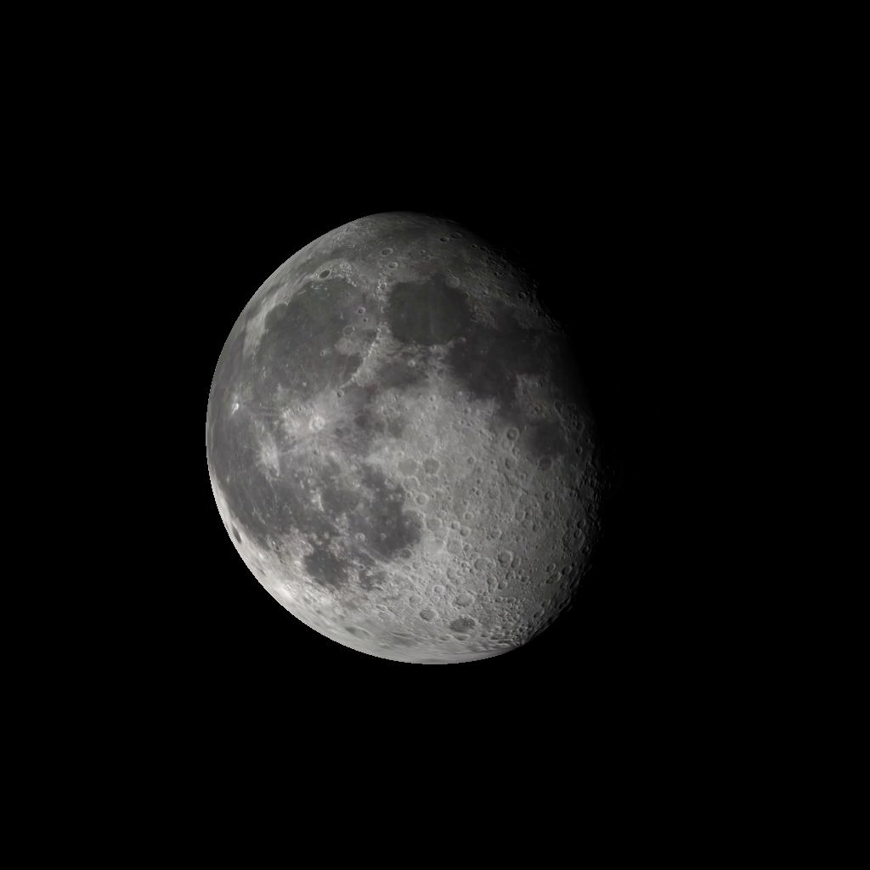  Waning Gibbous
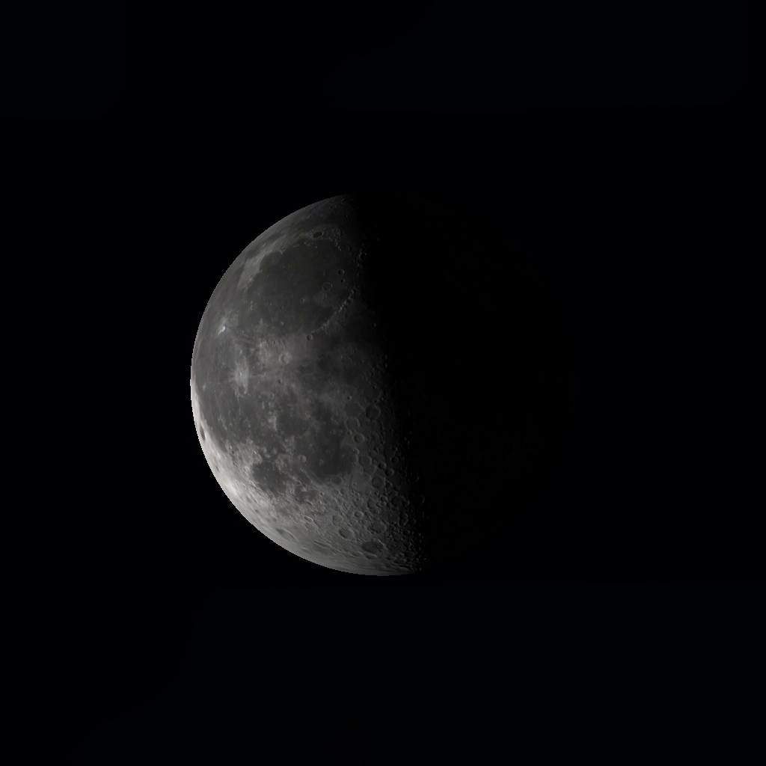  Half Moon  (last quarter) | 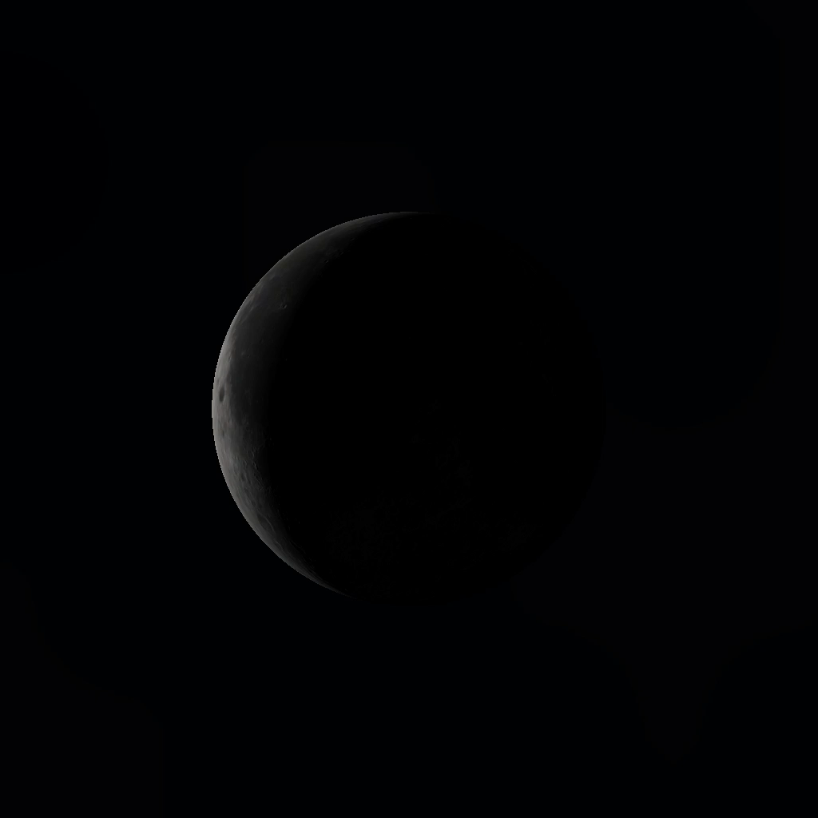  Waning Crescent | New Moon

New Moon | Crescent Moon
Half Moon | Full Moon

Copyright: Megan Argo 2019. Made using Stellarium.

