We Share the Same Moon Needs YOU!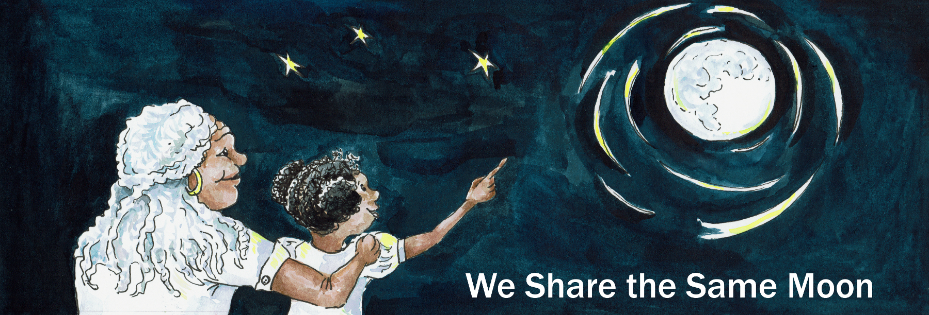

The aim of We Share the Same Moon is to create story-based resources for use in science education - in formal and informal settings around the globe. But how useful is it?

Help us to find this out - by filling in this form - be part of an evaluation of our website - with as many people and places as possible around the world

In return - we will send you exclusive access to images, videos and activities that are not on the website - to help you to make the most out of your event

Can you tell us

Your Name

Country where based or where working if different:

Date of event planned:

Location of Event:

Who is it for?

Numbers and ages of expected participants ?

What are you planning to do?

How will you be using our resources?

And send it to: Cassandra Wye - [cassandra.wye@gmail.com](mailto:cassandra.wye@gmail.com)

Many thanks!